he Official Publication of ALOA—An International Association of Security Professionals

Uovember 2003

**A rare car and a rare new tool**

**1999 Isuzu Vehi-CROSS**

**Lockmasters’ RATTail Personal Fault Code Reader**

Breck H. Camp CML POBox47070 Atlanta GA 30362-0070

MU tMl.,..UL.tl...l 11 (Hi till I illlln 11 il ill

Plus:

The Magic of Spherical Master Keying,  
The New Face of Schwab,

A Pair of Gun Safes,  
and much more!

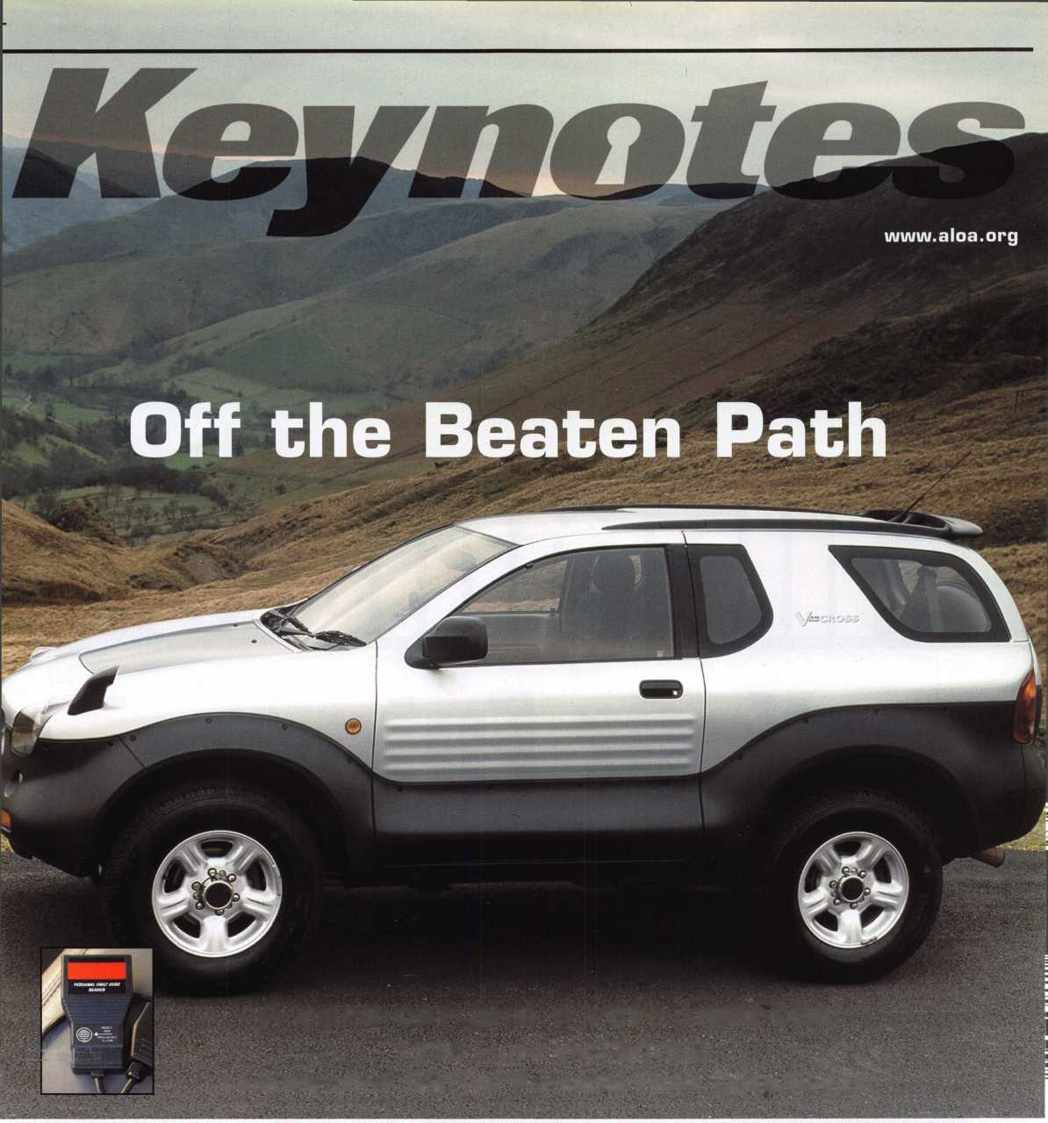

Your Future

Join us next summer at the East Coast's premiere travel destination as we set the stage for the biggest security event in the world. Come to Baltimore and discover classes, workshops, and exhibits that will help you shine in today's marketplace.

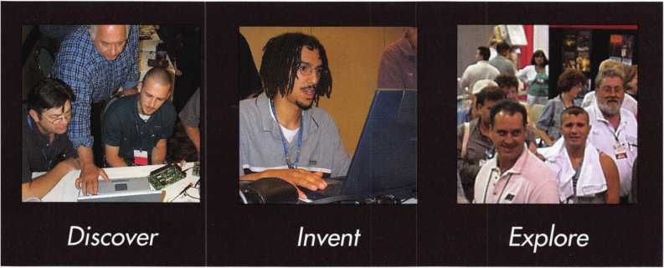

get it... together

The ALOA Convention and Security Expo • Baltimore Convention Center • July 1 9-25, 2004 • (800)532-ALOA(2562)

[convention@aloa.org](mailto:convention@aloa.org) • [www.aloa.org](http://www.aloa.org)

New Ownership New Outlook New Era

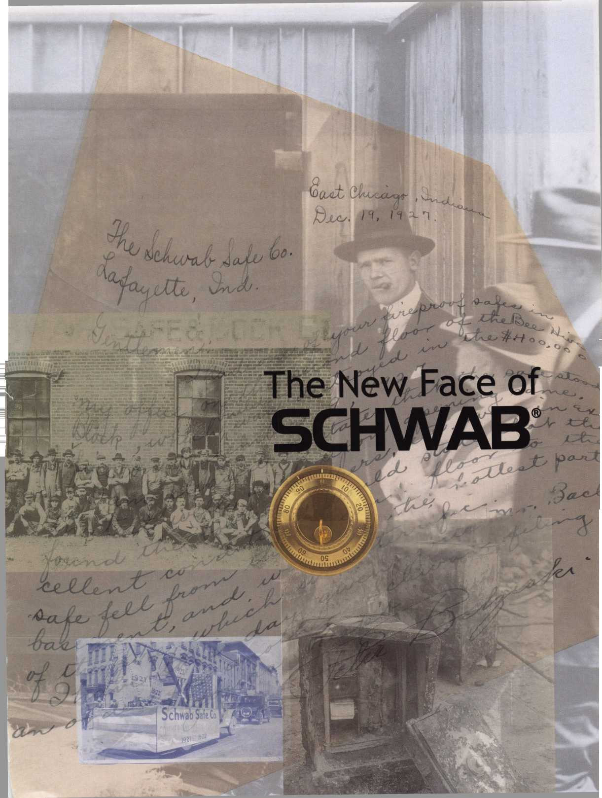

|  |  |  |
| --- | --- | --- |
| p r e s i d | e n 1 | Mai |
| p e n n | i n c  V- | J s |

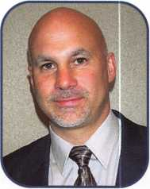

Dear Members,

An automotive issue in a trade magazine is always dear to my heart,  
because, I am (among other things), an automotive locksmith. I think  
back fondly to those that inspired me and helped me become proficient  
in the trade. Don O'Shall had a great book in the 1970s, "Simplified  
Foreign Auto Locks," which took the mystery out of foreign cars. Jerry  
Levine and Tom Seroogy taught me the domestic models. Hank Spicer  
taught me how to "File for Dollars." Patrick Sullivan taught me how to

professionally unlock cars. And the list goes on ...

Automotive manufacturers have increasingly tried to make their vehicle locking systems dealer serviceable only. This has only succeeded in generating greater resolve in a new generation of automotive experts in the locksmith industry. Don't tell us we can't do something - we'll find a way! The manufacturers make more secure locks, and we make better tools! We'll pick them, decode them and program new keys. The more secure the vehicle, the more lucrative the job.

For those of you who have dropped out of the automotive lock service business, I encourage you to partake of the educational opportunities that are out there in this area. ALOA is actively pursu­ing passage of the Motor Vehicle Owner's Right to Repair Act, which will once again level the playing field in this specialty field. Don't pass up an opportunity to add profits to your business!

Moving on to another specialty area, I attended my first SAVTA board meeting. For those of you that don't know, ALOA owns SAVTA but the two are operated separately. The ALOA board con­stitutes the shareholders of SAVTA, and as such, we elect that board. It is always a difficult task because there is a glut of talented and qualified candidates. This year was no exception. Skip Eckert, CML, will once again lead SAVTA as president, with a strong board consisting of Ron Snively, CML, CPS, Ron Jewell, John Greenan, CML, CPS, Owe Bengsston, and Tim Abner. SAV­TA continues to grow in numbers, and puts on the premier trade show for safe technicians in the world. My congratulations to the SAVTA board and my best wishes and support for continued success.

I am off to chair my first ALOA board meeting. I'll be reporting on that next month. Sincerely,

William L. Young, CML

Keynotes • November 2003

INTRODUCING THIi XTENDED LINE FROM STRATTI (

TRANSPONDER KEYS, TRADITIONAL KEYS AND PROGRAMMING

TOOLS FOR OVER A DOZEN MAJOR WORLDWIDE AUTO BRANDS  
FROM YOUR ONE TRUSTED SOURCE FOR QUALITY AND SERVICE

I*

NY

**KEYS FOR JUST ABOUT EVERY CAR ON THE PLANET.**

M STRATTECXL

**yy/ ONE SOURCE. MANY SOLUTIONS.**

|

!

£

t

1

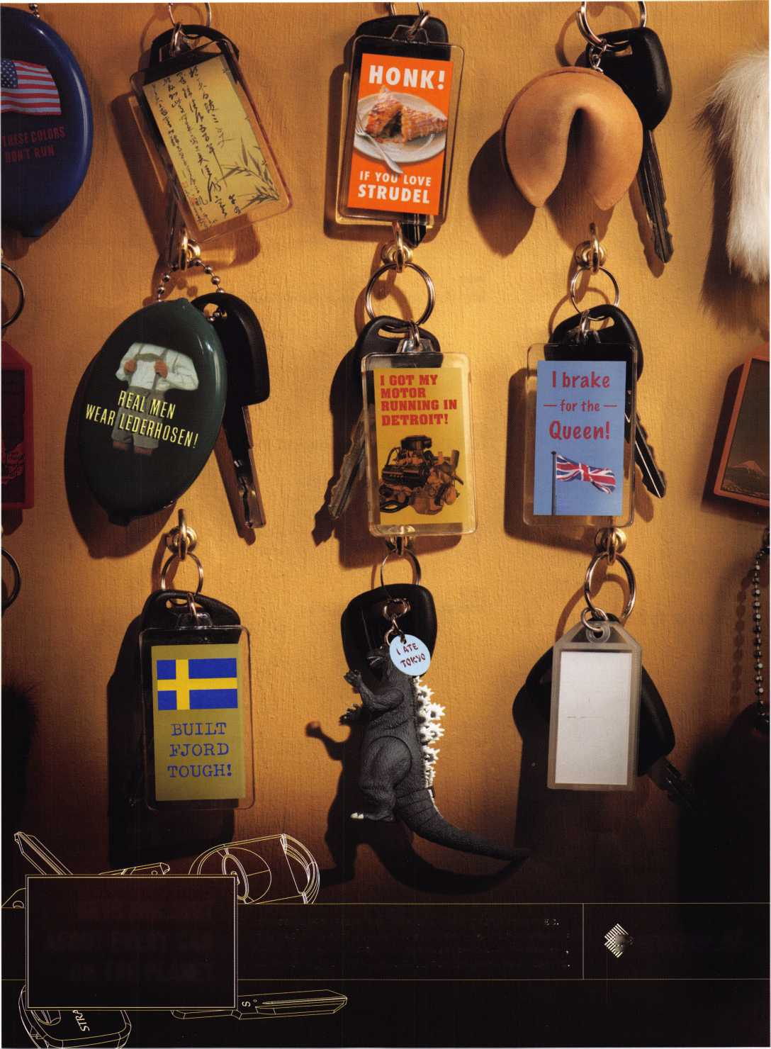

f

e a

t

u

res

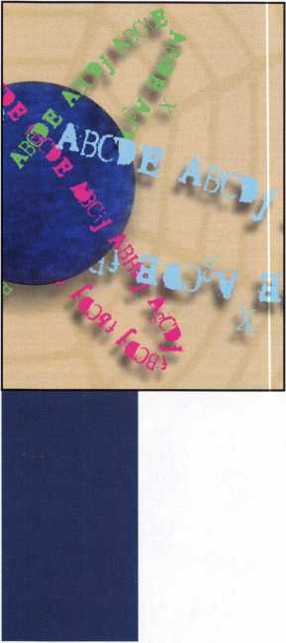

**departments**

Executive 5

Applicants 6

Calendar 8

Core 10

Legislative Update 38

Classifieds 40

Associate

Members 42

Back Page 44

THE AUTO ISSUE

**12**

Off the Beaten Path: 1999 Isuzu Vehi-Cross By Jeff Trepanier, RL  
The VehiCROSS was first shown as a concept Vehicle in 1993 at the Tokyo  
Motor Show where it garnered quite a reaction. It has been available in its  
home market for a few years and won Japan's "Car of the Year" award in  
1997. Although you can use information from this article to service other cars,  
this is an off-the-beaten-track sort of vehicle, any way you slice it. But as long  
as you approach it the right way, it should make you some easy money should  
it ever cross your path.



RATTail Personal Fault Code Reader **By Tom Seroogy**

New opportunities for todays electronic automotive locksmith! The advent of  
transponder technology and the proliferation of automotive electronics has  
brought with it a tidal wave of tools, technology and niche services. From  
transponder keys to remotes, the changes often leave the automotive locksmith  
drowning in a pool of possibilities with, sometimes, too few means for  
keeping afloat.

**22**

The Magic of Spherical Master Keying ByEncCos^cRL

There are a few things about master keying that regularly tend to make me  
cringe. Customers often want certain areas cross keyed, which immediately  
puts a glitch in your mathematical progression. I despise cross keying, and  
generally spend a great deal of time trying to explain to the end user that  
cross keying is, at best, not only difficult, but inadvisable. Even so, I occasion-  
ally find myself eventually succumbing to a customers very specific desires. But  
now I don't have to.

**26**

A Pair of Gun Safes

By Greg Perry, CML, CPS

This month, well look at a couple of gun safes, one Liberty and one Amsec that looks more like a Sentry, especially inside. Well also look at a Hamilton Night Depository opening I did recently. Safe openings come in all shapes and sizes. The vast majority of my openings are pretty easy. This one was not!

**32**

Opinion: Associations: Are They Working? **Byjim Hancock, crl**

Yes and no. That's the only answer that you could realistically give for this question. There is no black and white answer any longer, only shades of gray. For some groups, associations work well. For others, it seems to be a lost bat­tle. How can we all pull together and maximize the value of the memberships we have?

**36**

The New Face of Schwab

Founded in 1 872, in Lafayette, IN, Schwab Safe Company is one of Indiana's oldest continuously operational manufacturers. The Schwab Safe Company's early credits include vault doors and safes, baby buggies and horse-drawn carriages, as well as a wide array of castings. Today, Schwab is a modern safe manufacturer in every way. Here's a look at the Schwab of today.

Visit our website at [www.aloa.org](http://www.aloa.org)

executive

Volume 49, Issue 10



Additional contact information for the ALOA Board and most Keynotes authors is  
available through "Locksmith Search'" on the ALOA Web site- [www.aloa.org](http://www.aloa.org) or by  
contacting the ALOA office at 3003 Live Oak Street; Dallas, TX 75204; (800)532-2562;  
FAX (214)827-1810; e-mail [aloa@aloa.org](mailto:aloa@aloa.org).

|  |  |
| --- | --- |
| Editor  Jim DeSimone | [editor@aloa.org](mailto:editor@aloa.org) |
| Technical Editor  David Lowell, CML, CMST .... | [david@aloa.org](mailto:david@aloa.org) |
| Editorial Advisor  John D. Cannon, CML | [jdcannon@worldnet.att.net](mailto:jdcannon@worldnet.att.net) |
| Art Director  Betty Henderson | [betty@aloa.org](mailto:betty@aloa.org) |
| Advertising Sales  Kim Hammond | voice: 817-645-6778  Fax: 817-645-7599 e-mail: [adsales@aloa.org](mailto:adsales@aloa.org) |
| Executive Director  Charles W. Gibson, Jr., CAE | [charlie@aloa.org](mailto:charlie@aloa.org) |
| Convention & Meetings Manager  Jo Anne Mims [joanne@aloa.org](mailto:joanne@aloa.org) | |

PRP/Education Manager

David Lowell, CML, CMST [david@aloa.org](mailto:david@aloa.org)

Operations/Membership Manager

Mary May [mary@aloa.org](mailto:mary@aloa.org)

Government Relations Manager

Paul Kanitra [paul@aloa.org](mailto:paul@aloa.org)

IT Operations Manager

Greg Jackson [greg@aloa.org](mailto:greg@aloa.org)

Comptroller Kathy J. Romo

Membership Coordinator Shelly Jett

Convention & Meetings Assistant Karen Lyons

PRP/Education Coordinator Esperanza Rodriguez

Accounting Coordinator Stephanie Brothers

Mail Room Coordinator Kevin Wesley

Receptionist Bryan Dease

Contributors

Jerome Andrews, CML  
Paul Chandler, CRL  
Claire Cohen, CML  
Brian Costley, CML, CMST  
Eric Costley, CRL

Ray D'Adamo, CML Sal Dulcamaro, CML Billy Edwards, CML Dan Graffeo, CRL,CMST Jim Hancock, CRL

A.J. Hoffman, CML Jeff Nunberg, CML, CMST Randy Simpson, CML Robert Stafford, CML Dave Thielen, CML

Greg Perry, CML,CPS Tom Seroogy Charles Stephenson, CPS Dennis Watanabe, CML, CMST

Mission Statement: The Associated Locksmiths of America, Inc. is dedicated to enhancing the professionalism, education and ethics among  
locksmiths and those in related sectors of the physical security industry. With approximately 10,000 members in the United States, Canada and the  
freeworld, ALOA is poised to help members obtain the knowledge, the strength, and the confidence to perform their role in the physical security field  
with pride and dignity. But it is only through active involvement and participation that ALOA can fully achieve its potential—and can help members to  
achieve theirs.

Policies: **Keynotes**® is the official publication of the Associated Locksmiths of America, Inc. (ALOA). **Keynotes®** acts as a moderator without approving,  
disapproving, or guaranteeing the validity or accuracy of any data, claim, or opinion appearing under a byline or obtained or quoted from an acknowl-  
edged source. The opinions expressed by the authors do not necessarily reflect the official views of ALOA. Also, appearance of advertisements and  
new products or service information does not constitute an endorsement of products or services featured by the Association. The Association does not  
accept responsibility for the inaccuracy of any data, claim, or opinion appearing in this publication, due to typographical errors on the part of the  
authors, Association staff or its agents.

Editor's Note: This publication is designed to provide accurate and authoritative information in regard to the subject matter covered. It is provided  
and disseminated with the understanding that the publisher is not engaged in rendering legal or other professional services. If legal advice and other  
expert assistance is required, the services of a competent professional should be sought.

Authors' Payment: Payment for eligible submissions to Keynotes will be based on the following criteria: topic, time spent and past contributions. Authors who  
regularly submit to **Keynotes**® are generally paid a higher rate. The latter is especially true of authors who write to fit specific editorial needs and submit said copy  
by **Keynotes**® deadlines. As a general guideline: Average payment for a 750 word, business or 'light' technical article would be $200. Payment for a 1500 word  
article involving significantly higher time and research efforts would be $400.

Payment will not be offered for articles submitted by ALOA employees or members of the ALOA Board of Directors (unless material is of a technical  
nature), nor for articles submitted by a company that promote that company's products or services. ALOA reserves the right not to pay for articles sub-  
mitted by an individual(s) that promote a particular company's products or services.

Disclaimer: The Associated Locksmiths of America, Inc., (ALOA), reserves the right to refuse any article for any reason. Additionally, ALOA reserves  
the right to edit, amend or modify any article submitted for publication in order to preserve technical accuracy, clarity, fairness or grammatical cor-  
rectness. ALOA will make the best efforts to notify the author of any changes. The extent of ALOA's liability for any article or information contained  
therein will be a notice of correction or retraction in the next possible issue.

**Keynotes**® (ISSN 0277 0792) is published monthly except for the combined June/July issue by The Associated Locksmiths of America, Inc., 3003 Live Oak St., Dallas, TX 75204-6186. Telephone: (214) 827-1701; FAX (214) 827-1810; e-mail [aloa@aloa.org](mailto:aloa@aloa.org). Subscription rates for members—$15.00 per year. Periodical class postage paid at Dallas, Texas. POSTMASTER: Send address changes to: Keynotes, 3003 Live Oak St., Dallas, TX 75204-6186. © Copyright 2003, All rights reserved. No part of the contents may be reproduced or reprinted in any form without prior written permission of the publisher.

President

William L. Young, CML  
(610)647-5042

[president@aloa.org](mailto:president@aloa.org)

Secretary

John D. Cannon, CML  
(703) 960-6413  
[secretary@aloa.org](mailto:secretary@aloa.org)

Directors, Northeast

Robert E. Mock

(856) 863-0710  
[nedirector@aloa.org](mailto:nedirector@aloa.org)

Peter Sarailian, CRL  
(973)890-9797  
[nedirector@aloa.org](mailto:nedirector@aloa.org)

William L. Young, CML  
(610) 647-5042

[nedirector@aloa.org](mailto:nedirector@aloa.org)

Directors, Southeast

Tom Gillingham, Jr., CML, CPS  
(615)264-0747  
[sedirector@dloa.org](mailto:sedirector@dloa.org)

Ken Kupferman, CPL  
(813)961-5784  
[sedirector@aloa.org](mailto:sedirector@aloa.org)

Directors, North Central

Mark E. Blum, CML, CPS  
(517) 482-5809  
ncd i rector@a loa.org

John Soderland, CML, CMST  
(414) 327-5625  
[prolock@aloa.com](mailto:prolock@aloa.com)

Director, South Central

CD Lipscomb, CML, CPS  
(903)874-3522

[scdirector@aloa.org](mailto:scdirector@aloa.org)

Directors, Southwest

Gordon R. Racine, CML  
(719) 384-4707  
swdirector@aloa. org

Julie McCluney, CRL  
(714) 636-5652  
[swdirector@aloa.org](mailto:swdirector@aloa.org)

Director, Northwest

Scott L. Henke, CPL, CPS  
(907) 248-3785  
[nwdirector@aloa.org](mailto:nwdirector@aloa.org)

Director, European

Hans Mejlshede, CML  
(453)539-3939  
eurdirector@aloa. org

Director, Asian

Joe J. Lee, CRL  
(215)289-2404  
[asiandirector@aloa.org](mailto:asiandirector@aloa.org)

Director, Associate

Paul M. Justen  
(800)333-6953  
[asdirector@aloa.org](mailto:asdirector@aloa.org)

Trustees

[trusfees@aloa.org](mailto:trusfees@aloa.org)

Randy Simpson, CML  
(281)240-5959

JohnJ. Greenan, CML, CPS  
(773) 486.2030

Dallas Brooks  
(334) 826-8990

Past Presidents

2001-2002 Randy Simpson, CML  
1999-2001 John Greenan, CML, CPS  
1997-1999 Dallas C. Brooks  
1995-1997 David Lowell, CML, CMST  
1993-1995 Breck Camp, CML  
1991-1993 Henry Printz, CML  
1989-1991 Evelyn Wersonick, CML, CPS  
1987-1989 Leonard Passarello, CPL  
1985-1987 Joe Jackman, CML  
1983-1985 Stanley Haney, CPL  
1981-1983 Louis LaGreco, CPL  
1979-1981 John Kerr, RL  
1977-1979 Clifford Cox, CML  
1974-1977 Charles Hetherington  
1972-1974 Gene Laughridge  
1970-1972 William Dutcher, RL  
1968-1970 Constant Maffey, RL  
1966-1968 Harold Edelsfein, RL  
1964-1966 William Meacham  
1962-1964 Robert Rackliffe, CPL

1960-1962 Edwin Toepfer, RL

Keynotes • November 2003

AKL

NV

**assa**

Family Of Locks

Cabibet Lock

Door Tube Lock

Exterior Wall Tube Lock

Removable Core Cylinder

Cam Lock

ASSA*

We Secure The World

, Inc.

110 Sargent Drive

New Haven, CT 06511

(800) 235-7482  
Fax (800) 892-3256

ASSA Canada 3475 14th Avenue Markham, Ontario L3R OH4 Canada

[www.assalock.com](http://www.assalock.com)

an ASSA ABLOY Group company

ASSA ABLOY

Florence

James D. Peebles Jr

Sponsor: John P. Luhrs CRL

Jackson

Larry Smith

Sponsor: Bruce J. Tar- bet CML, CPS New Market

Ken Harris

Sponsor: Ernest W. Wright

***CA***

Benicia

Deborah R. Skau

CO

Fort Collins

Tom Martinez

Sponsor: Wayne Younger CML

CT

Enfield

Stephen G. Munz

Sponsor: Richard W. Shaw Waterford

Peter Doherty

FL

Crestview

Deri Justice

Sponsor: Bruce J. Tar- bet CML, CPS

Loxahatchee

John W. Potts

Sponsor: Vincent L. Formon CML, CPS

GA

East Ellijay

Bruce N. Reagin

Sponsor: John C. Elliott Jr, CML, CPS

IA

Rein beck

Robert F. Gutknecht

Sponsor: Rick W. Bar­rett

IL

Steger

Ronald E. Urzen- dowski

Sponsor: William T. Beranek

Elko

Charles D. Price

OH

KS

Kansas City

Charles E. Wendt CRL

Sponsor: Clifford D. Lipscomb CML, CPS Overland Park

David J. Moore

Sponsor: Clifford D. Lipscomb CML, CPS

LA

Houma

John D. LeBlanc

Sponsor: Bruce J. Tar- bet CML, CPS Natchitoches

Craig Bumgard- ner

Sponsor: Bruce J. Tar- bet CML, CPS Walker

Eric E. Jones Sponsor: Randall R. Jones CRL

ME

Hallowell

Jeffrey S. Truman CRL

Ml

Alpena

Michael F. Agius

MO

Blue Springs

Frank L Goet- zfridt

Sponsor: Rollin R. Gilliland CPL, CPS Grandview

Thomas C. Healey

Sponsor: Clifford D. Lipscomb CML, CPS

NH

Claremont

Glenn Rivet

Sponsor: Peter Deutsch

Cincinnati

Claude W. Lindsey

OR

McMinnville

Jody S. Fisher CRL

PA

Harrisburg

John F. Shinkowsky

Rl

Westerly

David D. Syren

TN

Knoxville

John Yates

Sponsor: Curtis L. Clanton Selmer

Branton Jones

Beloit

John R. Stewart

WV

Martinsburg

Ian A. Edwards

Sponsor: Max A. Mosse

Sponsor: Max A. Mosse

Canada

Mississauga, ON

Alvin Dorder

Penetany, ON

Sean W. Baxter

Thornton, ON

William A. Rawn

land

Nottingham

Martin Pink

Sponsor: Ken Dale

Chicago

Jose M. Hernan­dez Jr

Countryside

Robert F. Mance

NJ

Cherry Hill

Justin Trueland

Sponsor: Louis Gildenberg CPL

These applicants are scheduled for clearance  
tively, to ensure applicants meet standards of  
applicants (a) have worked in the industry two

as members of ALOA. The names are published for member review and comment within 30 days of this Keynotes issue date, respec-  
ALOA's Code of Ethics. Protests, if any, should be addressed to the Membership Department and must be signed. Active Membership  
or more years. Allied Membership (AL) applicants are not locksmiths, but work in a security-related field. Apprentice Membership (AP)  
applicants have worked in the industry less than two years.

Keynotes • November 2003

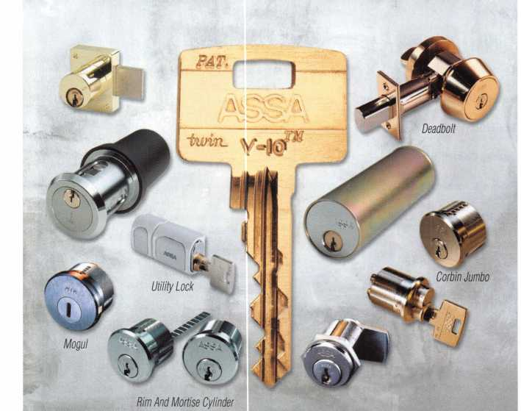

**Fastening Solutions**

TECHNICAL SALES, INC.

**Pearl Technical Sales**

***featuring sex bolt solutions from***

ccurate

ccessories

MADE IN USA

Sex Bolt Hardware and Fasteners - In stock for immediate shipment.

• Sex Bolts - Standard and Custom Sizes • Custom Service

* Sex Bolt Assortment Kits
* Barrel Bolts
* Binding Posts
* Connecting Bolts
* 50 Piece Minimum custom order
* Quick TurnAround
* CNC manufactured, Top Quality
* Brass, Stainless Steel, and Steel materials
* Architectural finishes

|  |  |  |
| --- | --- | --- |
|  |  |  |
|  | 1 | [0 | \ |
|  |  |  |
|  |  | 0 U |

TECHNICAL SALES. INC.

17Timbercrest Lane _ _ . _ _ _ _ . __ _ _ - __

south setauket, ny 11720 Phon©i 631 "698-7173 • Fsxi 631-736-5467

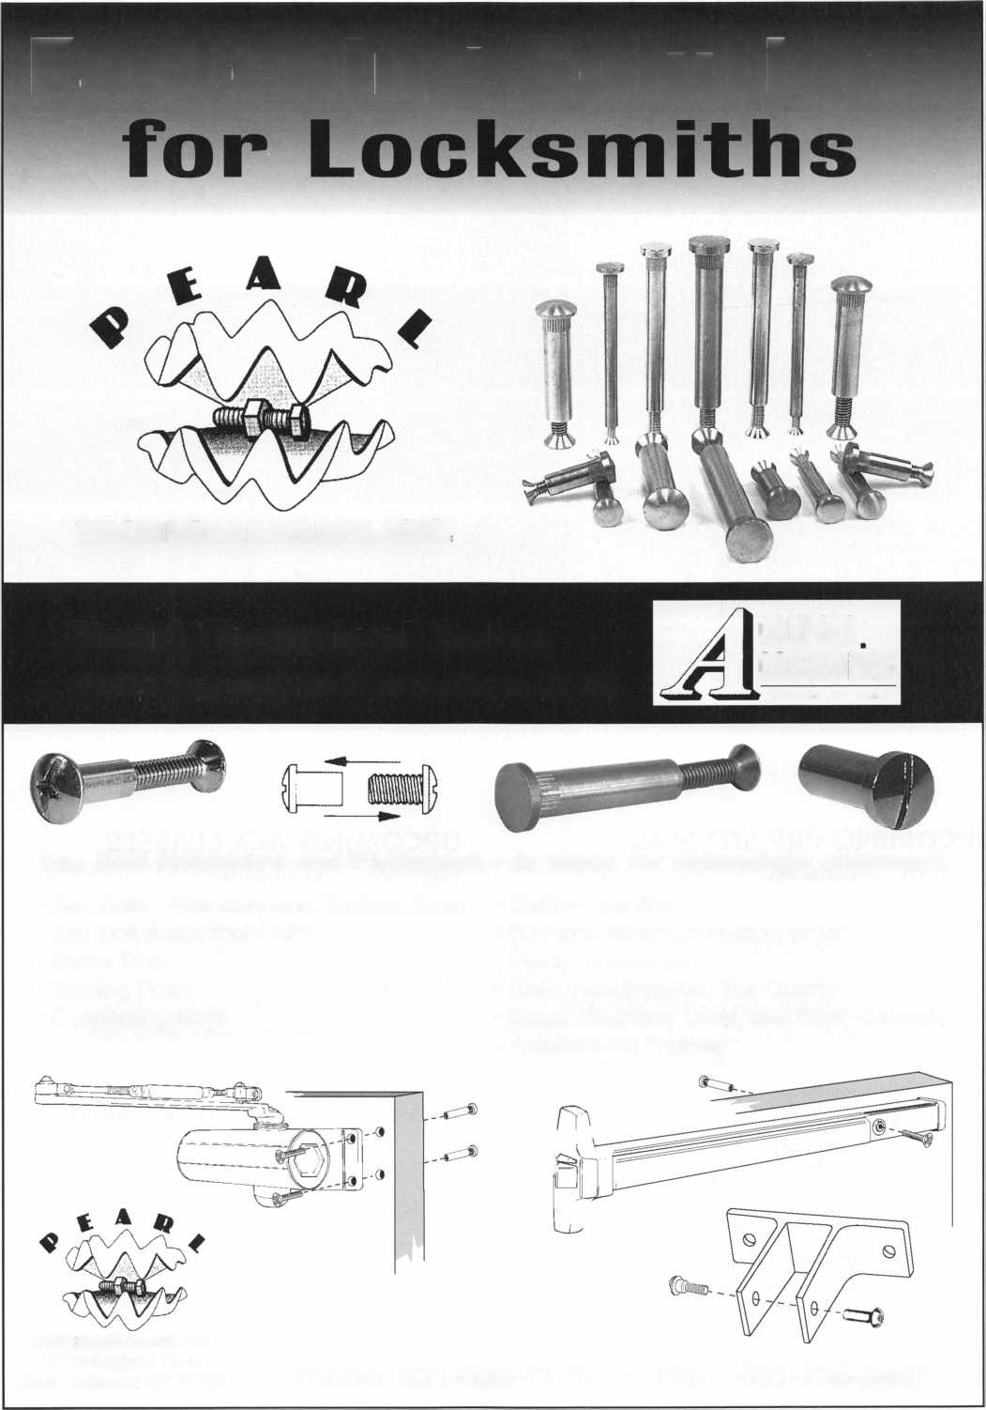

**JAN | DEC NOV**

|  |  |
| --- | --- |
| p c o | ming events |
| 5 Minnesota Chapter | 5 Ohio Valley Chapter of ALOA |
| Regular Meeting | Membership Meeting 7pm |
| Dave Nissen | Ryan's Steak House |
| [mnchapternews@aol.com](mailto:mnchapternews@aol.com) | Middletown, OH (off exit 32) |
|  | Mehdi Zahedi (937) 294-4241 |



|  |  |  |
| --- | --- | --- |
| 3 Minnesota Chapter | 3 | Ohio Valley Chapter of ALOA |
| Regular Meeting |  | Membership Meeting 7pm |
| Dave Nissen |  | Middletown, OH (off exit 32) |
| [mnchapternews@aol.com](mailto:mnchapternews@aol.com) |  | Mehdi Zahedi (937) 294-4241 |

**UPCOMING PRP SITTINGS**

UPCOMING ACE CLASSES

|  |  |  |  |
| --- | --- | --- | --- |
| 11/8/2003 | Detroit, Ml  Locksmiths Security Association  Maurice Horne, CML  313-550-5810 | 11/1/2003 | Randolph, MA  The Flying Locksmiths, Inc.  Barry McMenimon, CRL 781-963-5080 |
| 11/13/2003 | 8:00AM • Dallas, TX • ALOA  Hope Rodriguez 800/532-2562 X30 | 11/1/2003 | Detroit, Ml  Locksmiths Security Association |
| 11/16/2003 | TBD • Montgomery, AL  Alabama Locksmiths Assn.  Amanda Boyd 334/793-5060 |  | Life Safety Codes and the ADA  Maurice Horne, CML  313-550-5810 |
| 11/16/2003  12/11/2003  12/14/2003 | 8:00 AM • Ellicott City, MD  Clark Security Products  Joan Emrick 619/718-7308  8:00AM • Dallas, TX • ALOA  Hope Rodriguez 800/532-2562 X30  9:00 AM • Fairborn, OH  Ohio Valley Chapter  William M. Lockwood, CRL  937/775-2154 | 11/15/2003 | Montgomery, AL • AL Locksmiths Assn Amanda Floyd 334-793-5060  Closed Circuit TV for Locksmiths |

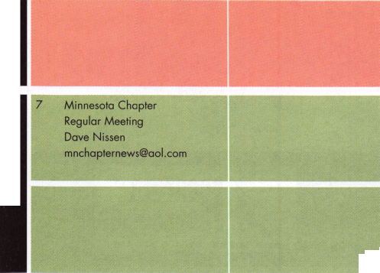

41ST ANNUM CONVENTION & TRADE SHOW  
IN THE HISTORIC MARKET DISTRICT ON GAIVESTON ISLAND  
FEDRUARY 24 - 20, 2004

* FREE CLINICS
* FREE SEMINARS
* GENERM MEMRERSHIP  
  MEETING
* ELECTION &  
  INSTALLATION  
  OF NEW OFFICERS
* PRODUCT EXHIHT
* SCHOLARSHIP  
  RAFFLE
* BANQUET DINNER, CASI-  
  NO PARTY

FOR MORE INFORMATION CONTACT:

AIOA AGE GLASSES

Wednesday, February 25.2004:

Investigative Locksmithing l Automotive Key Generation

Electronic Safe Lock Servicing & Troubleshooting Small Format 1C • P-38

Thursday, February 26,2004: investigative Locksmithing II Advanced Transponders

Combination Lock Servicing & Troubleshooting Large format 1C • P-39

Friday, February 27,2004: investigative Locksmithing III Remotes & Automotive Update Safe Deposit Locks Motorcycle Locksmithing • P-22 Basic Safe Penetration Tubular Key Locks • P-12

“P-#” indicates PRP certified classes

Butch Titus, Secretary • P.0. Box 142 • Adkins, TX 78101 • 210-649-2166

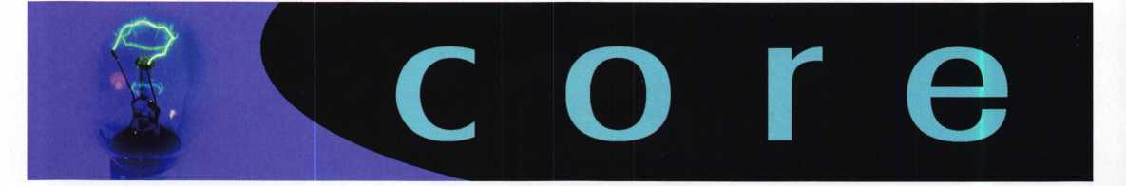

In Memory

The ALOA community has recently lost a wonderful member. The wife of ALOA Lifetime of Outstanding Achievement Award and Keynotes Author of the Year recipi­ent Dan Graffeo, CRL, CMST - has died tragically of a rare form of cancer. Lois Graffeo, CRL, an ALOA member, passed away this summer. On behalf of everyone at ALOA, we wish to extend our deepest sympathies to the Graffeo family.

ALOA Code of Ethics

All members of the ALOA by acceptance and continuance therein, shall be deemed to have subscribed to the following Code of Ethics:

That the dignity of our chosen profession may be perpetuated, it is the duty of all members of the ALOA.

* To practice their profession in the spirit of fairness to their clients, with fidelity to security in conformance with appropriateness, and with high ideals of personal honor;
* To properly and impartially analyze security problems, and to advance the best possible solution for the protection of their clients;
* To conduct themselves in a dignified manner;
* To abide by applicable licensing and business regulations;
* To abstain from using improper or questionable methods of soliciting patronage, and to decline to accept such incompatible patronage;
* To refrain from associating themselves with or allowing the use of their names by any enterprise of questionable character, or in any manner countenancing misrep­resentation;
* To cooperate in advancing the best interest of the locksmithing industry by inter­change of general information and experience with fellow locksmiths;
* To encourage and promote loyalty to the profession, always ready to apply their special knowledge, skill and training for the use and betterment of our industry.

Let Us Know!

If you have an opinion to offer on ALOA, the state of the industry, or life in general, we want to know about it! Submissions to the "Mailbox" section of Keynotes are printed on a space-available basis. Write to: "Letters to the Editor"; ALOA; 3003 Live Oak Street; Dallas, TX, 75240; FAX 214/827-1810; e-mail: [editor@aloa.org](mailto:editor@aloa.org).

Need Help?

At ALOA, we want to make sure you are getting as much bang for your membership dues buck as we are able to give you. If you have had problems getting membership services, or have a question regarding member services, please contact Bill Gibson, exectuve director, at 800/532-2562, or e-mail: [charlie@aloa.org](mailto:charlie@aloa.org).

ALOA'S NEW CLEARSTAR OFFER!!

Starting in January 2004, all ALOA members who renew for the year will receive a $15 discount off of ClearStar membership (currently $45). This includes new and renewal memberships with ClearStar. Application must be made through ClearStar: [www.security](http://www.security) @clearstar.com

ALOA's POSITIVE ID POLICY:

* ALOA locksmiths are instructed to use the following positive identification policy when servicing lockouts:
* Notify Caller. When a call comes in to request lockout services, ask the caller if he/she has identification and authority to open the lock.
* Complete Form. Upon arrival at the job site, the locksmith should complete an Authorization Form that asks for the name, address, phone number, identification number and property description from the customer.
* Verify I.D. Verify the customer's photo-identification card and compare it to the information provided by the customer. If no photo-ID card is available, ask for some other reasonable form of ID.
* Verify Authority. The locksmith should inquire as to what authority the customer has to open the lock, and request to see any reasonable and appropriate evidence that could verify the authority. This may be impossible in some cases.
* Ask for Signature. Ask the customer to sign the Authorization Form, which should contain a statement that (a) the information given by the customer is correct, (b) the customer has the authority to open the lock, and (c) the customer shall identify and hold harmless the locksmith against liability.
* Optional Last Resort. If you have any suspicions that the customer is giving false information or does not have authority to open the lock, say that you will be happy to open the lock provided a law enforcement officer is present. If the cus­tomer agrees, call the police; if not, leave.

File the Form. Keep the Authorization Form on file for a reasonable period of time.

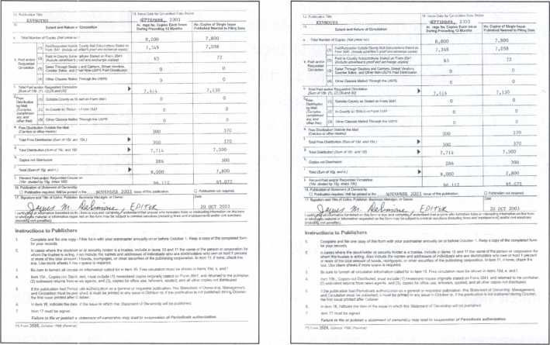

**SELF-STUDY GUIDEBOOK**

Ruaiiable as single modules (one CD and guidebook) or the full set (three CDs and three guidebooks).

Seruer uersions are  
also auailable!

**Self-Study Course**

**AL0A**

**SPECIAL**

FUNDAMENTALS OF:

**WiMM** IVSIII

**Get the award-winning  
*Fundamentals of Hrchitecture  
Doors and Hardware Self-Study  
Course* at a great price!**

The ultimate training tool for locksmiths... Now there is a complete in-house training

**program auailable! Order the** Fundamentals of architectural Doors and Hardware Self

**Study Course** three CD/guidebook series.

**To** order, call **(800)532-2562** or miiiLU.aloa.org.

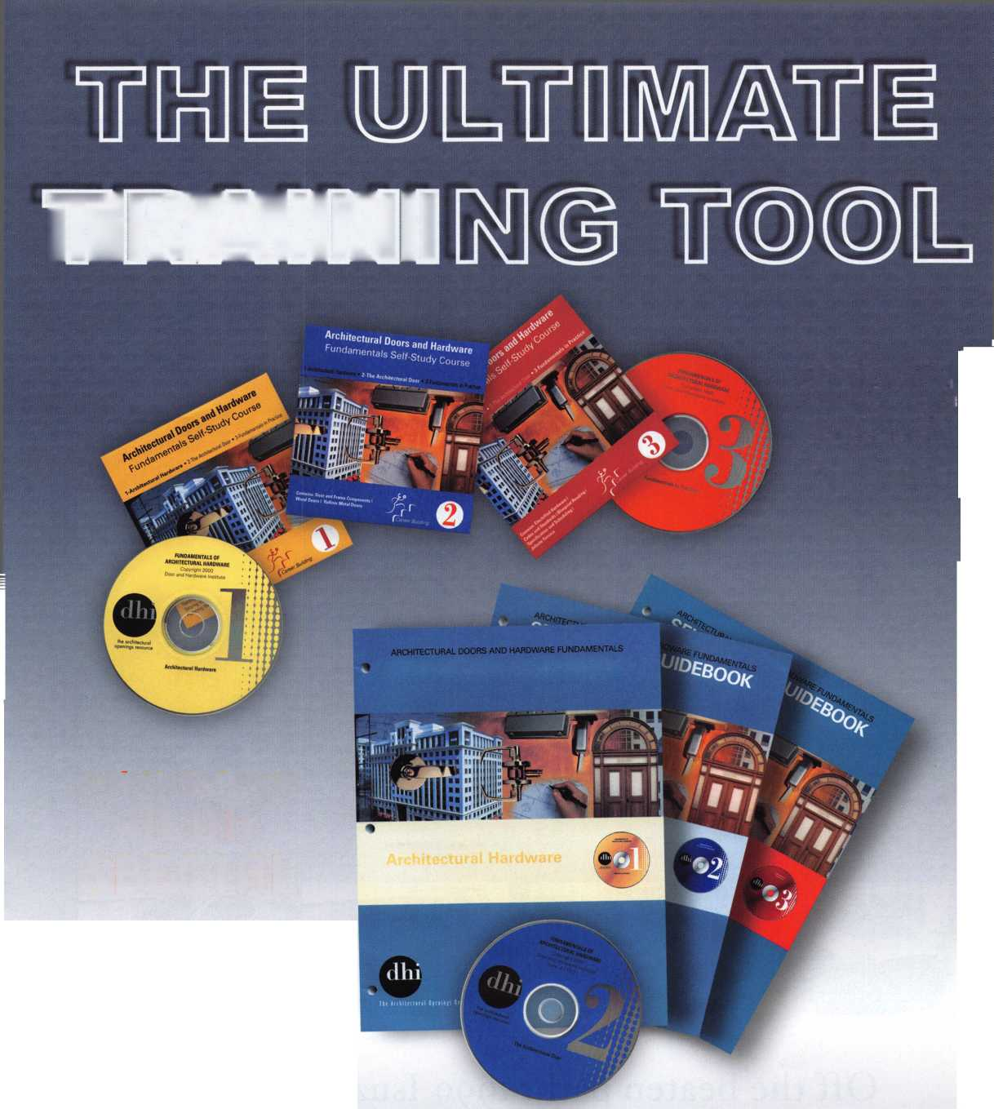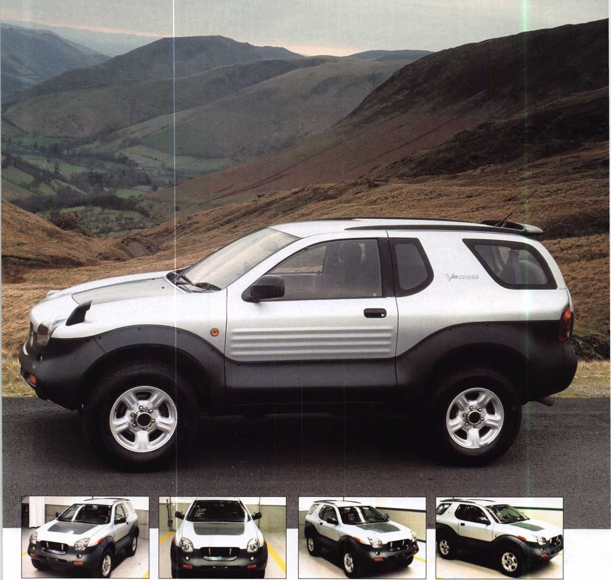

Off the beaten path: 1999 Isuzu Vehi-Cross

(Code Series N5001-N7000)

by Jeff Trepanier, RL

**2**

Keynotes • November 2003

The VehiCROSS was first shown as a concept Vehicle in 1993 at the Tokyo Motor Show where it garnered quite a reaction. It has been available in its home market for a few years and won Japan’s “Car of the Year” award in 1997. Advanced features include a spare tire that resides inside the rear tailgate and a roof-end spoiler that works as an air-deflector to keep the rear window free of water and dirt. Zinc-plated steel is used for the body with the lower section covered by a tough, recyclable polypropylene. Composite bumpers and under-body moldings complete the body design. It’s an off- the-beaten-track sort of vehicle, any way you slice it. As long as you approach it the right way, it should make you some easy money should it ever cross your path.

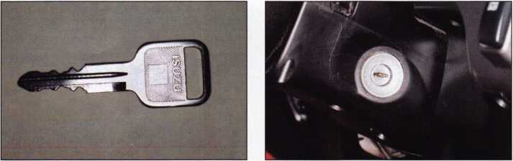

1. The non-transponder key.

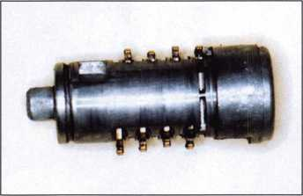

4. The lock plug with 8-wafers that are opposing.

1. Right side view of the steering column with the ignition cylinder look, off, acc, on, start. To remove the ignition, turn the cylinder to the off position (using a key) and push in on the active retainer about 1 Q inches from the edge of the face 180 degrees opposite the key buzzer switch.

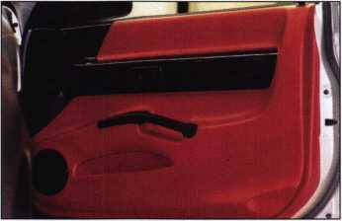

1. The passenger side door. To remove the panel, we will start by removing the door controls by gently pulling up at the front as it is hooked at the rear. Unplug the wires and then remove two Phillips screws from the left and right side of the door-pull cavity.

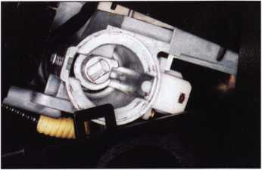

1. The ignition cylinder removed. To remove the lock plug, remove the retainer from the back and push the plug out toward the front.

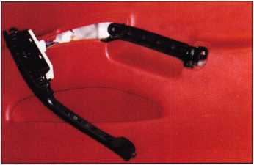

1. The controls and handle. You can see the clip at the front and how it would hook at the rear from the metal tab.

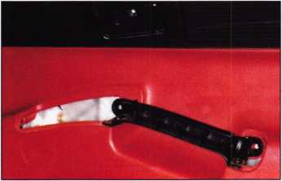

1. The door release handle. To remove the handle, just remove one Phillips screw. Now gently pull away the panel from the door. The door trim in the upper left corner may or may not be needed to be removed for door panel removal. I did not need to remove the trim.

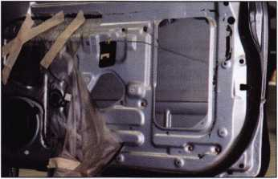

8. The door after the panel is removed.

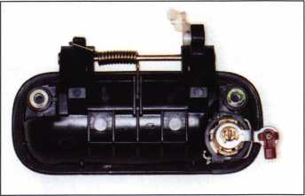

The back side of the door handle and the lock cylinder. It is not necessary to remove the handle to remove the lock. The handle was removed for photo purposes. To remove the lock, separate the spring retainer and pull the lock cylinder out.

It is not necessary to completely remove the spring. When installing the lock, just push it back in, and it will snap back into place.



Keynotes • November 2003

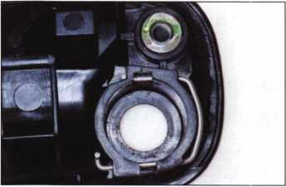

1. Close-up of the lock cylinder removed from the handle. Also seen here is a close-up of the lock retainer spring.

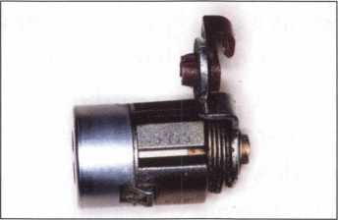

1. The door lock cylinder with the key stamped on it. Read the code carefully due to uneven stamp­ing, etc. Know your code series when searching for the proper code so you don’t read the code upside down, etc. The letter in front of the code is not completely stamped. The code is N6969.

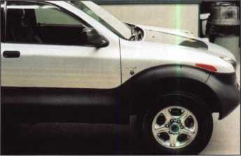

1. The passenger door and the front end of the vehicle.

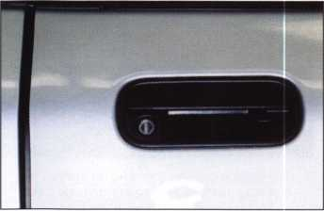

13. Close-up of the door handle. The opening tool is in position to open.

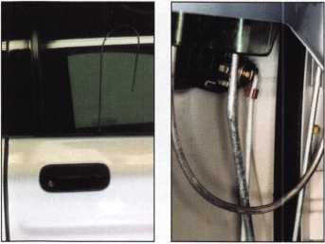

14. There are several types of opening tools that can be selected for lifting up the locking but­ton by getting under it. This vehicle, in my opinion, is very easy to open. This is not the only way to unlock the door; there are other contact points in the door.

15. Close-up of the bot­tom of the opening tool inside the door.

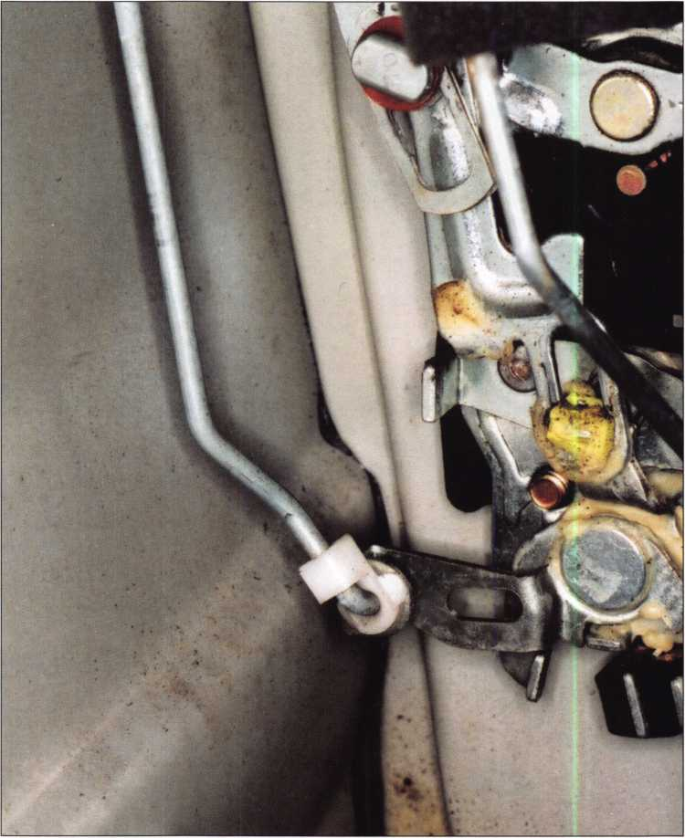

16. The bell crank assembly in the door.

Keynotes • November 2003

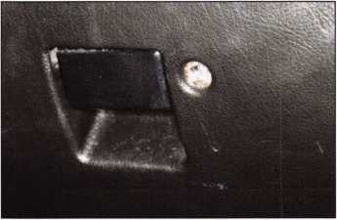

17. The glove box with a lock.

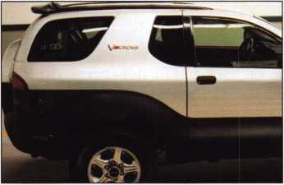

20. A side view of the right side of the vehicle, and the aircraft-style gas flap.

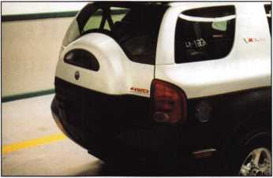

18. The rear of the vehicle and lock.

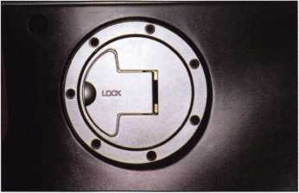

21. Close-up of the locking gas flap.

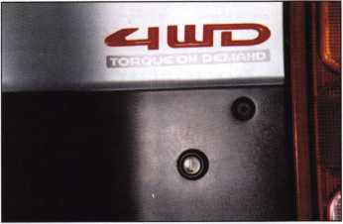

19. The rear lock.

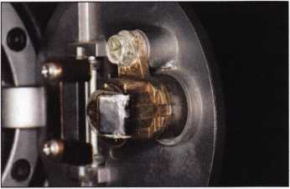

22. To save time and guesswork, I recommend that when fitting a key to this model vehicle that you go straight for the passenger’s door look and cut a key by the code number. This style lock system and code series are used on other models.



SAFE CORPORATION

Viking Stainless

Fire & Burglary Protection  
State of the Art Composite Fill

Strong • Functional • Attractive

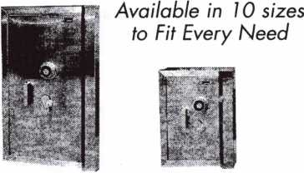

See us at [www.a-bsafecorp.com](http://www.a-bsafecorp.com)

1-800-253-1267 Fax 856-863-1208

CALL FOR YOUR CATALOG TODAY

Advertise with Weatherproof Safety Labels!

Lockout your  
competition

by placing your  
calling card on  
every door you  
service! Keep

your name in front  
of every customer  
with these Durable,  
Affordable Labels  
Call & Order Today  
1-800-355-6322

(Actual Label Size 1 1/2x4 1/2)

Professional Business Products

ALOA Associate Member

Check out our competitive prices on Invoices with two color ALOA  
logo, Repair Tags/Claim Checks, Business Cards, Door Hangers,  
Shirts, Hats, Pens, Key Tags, Magnets.

[www.professionalbusinessproducts.com](http://www.professionalbusinessproducts.com)

Keynotes • November 2003

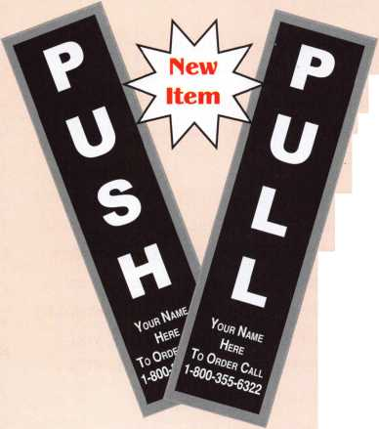

RATTail Personal Fault Code Reader

New opportunities for today’s electronic automotive locksmith!

By Tom Seroogy

The advent of transponder technology and the prolifera­tion of automotive electronics has brought with it a tidal wave of tools, technology and niche services. From transponder keys to remotes, the changes often leave the automotive locksmith drowning in a pool of possibilities with, sometimes, too few means for keeping afloat.

Among the newer and quickly growing niche services is vehicle diagnostics. While this service is not for every lock­smith, those that do their fair share of transponder and remote programming may find this service not only simple, but one that can be added to the routine of their automo­tive services without much, if any, added expense.

What’s vehicle diagnostics?

In short, from 1995 forward all vehicles sold and driven in the United States must meet OBDII standards. This EPA induced standard includes several requirements that allow a technician to scan a vehicle for reporting various problems in the car. Each problem is reported on the scan tool as a DTC, or Diagnostic Trouble Code.

For example, if a vehicle’s EGR valve or injection system is suffering from problems or failures, one or more DTCs may be recorded to indicate the problem(s). A technician retrieving the codes, is able to quickly diagnosed and cor­rect these problems.

Although the development and application of trouble codes is beyond the scope of this article; the fact that any techni­cian with a diagnostic tool can retrieve these codes makes it possible for a locksmith with a scan tool to earn a few extra dollars in doing so. Thus, if you’re using a scan tool to program transponder keys or remotes into vehicles, you already own all that is needed to retrieve a list of DTCs from the vehicles for which the tool is designed.

What markets are available?

Although any locksmith can benefit from offering diagnos­tic services, those doing work for the following markets stand to make the most from offering such a service:

* New and used car dealers
* Auctions
* Rental companies
* Tow and repo work
* States that require emissions tests

The first four customer bases on the list offer the most potential for a locksmith. To make money, speed in getting a car from the lot to the front line is critical. By offering a quick check of all incoming vehicles, the locksmith can help isolate problem vehicles before they hit the customer’s front line. By identifying problems while the car is still in the lot, there is a savings of the customer’s time and expense in shuffling the car back and forth between the lot, garage and front line. Currently, locksmiths performing this service charge an average of $20 to $50 per car.

As states move to using diagnostic tools to perform emis­sions tests, the potential for offering a quick pre-test scan is good. This service can be offered to customers whenever keys are made or duplicated for their cars. The average price is $20 to $35 per car.

What do I need?

If you are already doing transponder work and own original equipment diagnostic tools - i.e. NGS, Consult II, MUTII, etc. - the chances are you’re already capable of providing this service.

Still, even without these tools there are many inexpensive aftermarket tools that available for performing simple OBDII related system diagnostics.

It should be noted, however, that whereas OE tools offer the technician a full array of DTC’s on all vehicle systems, aftermarket tools are limited to emission related, OBDII DTCs.

One new tool, the Personal Fault Code Reader, dubbed RATTail, was recently tested by Lockmasters. (See photo­graph 1.)

Applications:

This tool is designed to interrogate, report and clear all OBDII diagnostic fault or trouble codes (DTC’s) on all 1996+ North American vehicles falling under OBDII standards and using the following protocols:

* ISO 9141
* J1850VPW
* J1850PWM
* KWP2000

I

**6**

Keynotes • November 2003

1

Operation

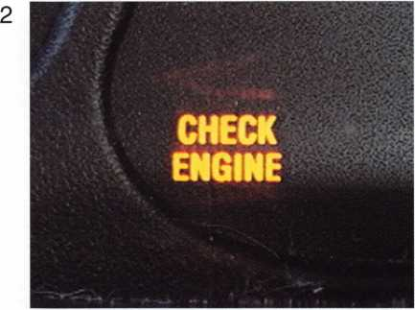

For our trial, we worked on a 1996 Ford Explorer. This par­ticular vehicle had been running for some time with the “CHECK ENGINE” light on. It was the perfect candidate for trying this new tool. (See photograph 2.)

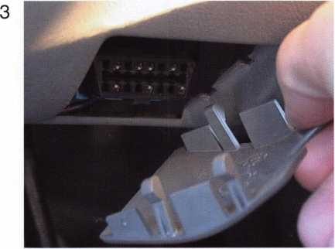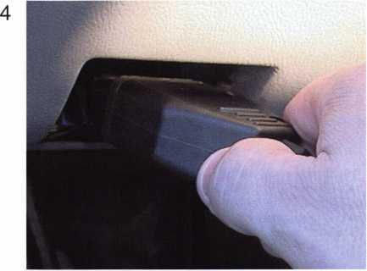

1. Plug RATTail unit into vehicle’s OBDII or Data Link Connector (DLC) port. (See photographs 3 and 4.)

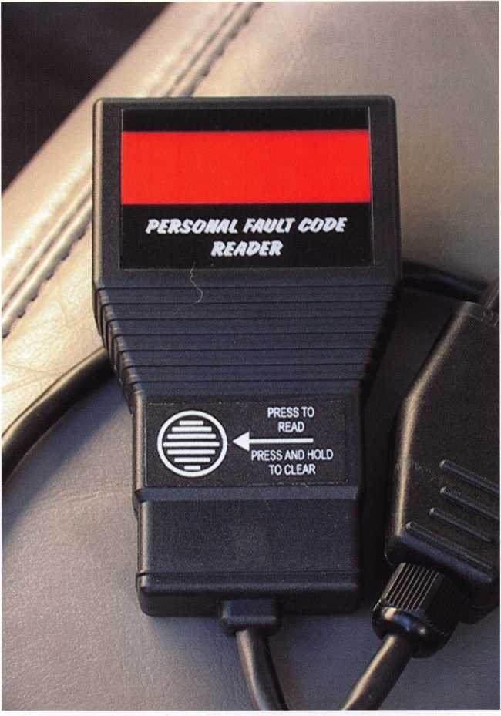

NOTE: The RATTail

does not work on  
North American  
vehicles using the  
newer CAN protocol.

Kevnotes • November 2003

5

Diagnostic Trouble Codes:

Anatomy

FIRST DIGIT

An alpha designation that indicates which control system triggered the code. Four letters are cur­rently used:

* P - Powertrain
* B - Body
* C - Chassis
* U - Unidentified (for future applications)

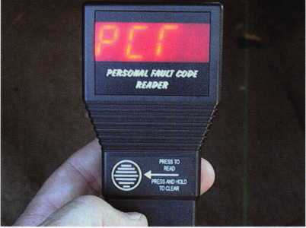

The RATTails or PCRs LED displays “PCR.”(See photograph 5.)

2. Turn ignition lock to ON position. Make sure that all indi­cator lights in the dash area light. If errors occur in read­ing, make sure that the ignition is in the ON position and not the ACC or LOCK/OFF position.

SECOND DIGIT

a numeric value of 0 through 3.

* 0 - indicates a generic SAE defined code.
* 1 - an enhanced SAE code, or code that is defined by the Original Equipment Manufacturer.
* 2 or 3 - reserved for future use by SAE or Original Equipment Manufacturer.

THIRD DIGIT

Indicates the subsystem where the trouble or fault occurred. The definition of the digit is depen­dant on under which system, indicated by the first digit, the subsystem lies. For example, if the first digit is “P” - Powertrain, the available third digits may be:

* 1 - Fuel or Air Metering
* 2 - Fuel or Air Metering
* 3 - Ignition or Engine Misfire
* 4 - Auxiliary Emission Controls
* 5 - Vehicle or Idle Speed Controls
* 6 - Computer or Output Circuit
* 7 - Transmission Controls
* 8 - Transmission Controls
* 9 - SAE Reserved for future use
* 0 - SAE Reserved for future use

Fourth & Fifth Digits - Indicate specific condi­tions that caused the trouble code. “00” is non­specific and indicates a generic or general mal­function. Other numbers can indicate low or high voltage signal, slow response, or out-of-range signal.

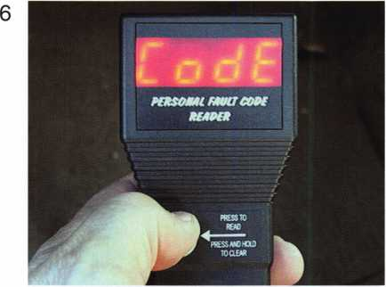

3. Begin by depressing the highlighted button on the PCR unit. If problems have been detected, the LED displays “CODE” to indicate that DTC’s are present. (See photo­graph 6.)

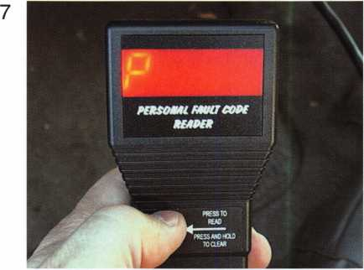

This is followed by a letter prefix - P, C, B, or U (see expla­nation below) - indicating the system with the reported problem(s). In the case of this vehicle a “P” is displayed, indicating that the trouble is originating in the Powertrain. (See photograph 7.)

**8**

Keynotes • November 2003

8

No Fault Codes Present

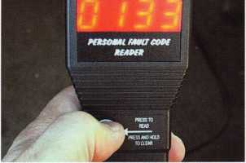

|  |  |  |
| --- | --- | --- |
| SEQUENCE | LED DISPLAY | STATUS/IDENTICATION |
| 1 | PCR | Introduction/Title message. Press button to proceed. |
| 2 | ... | Logging onto vehicle system |
| 3 | CODE | Checking for fault codes |
| 4 | DONE | Operation complete/no codes found. Press button to re-test. |

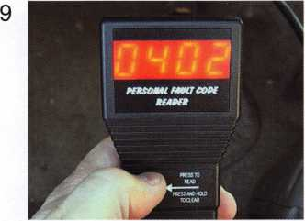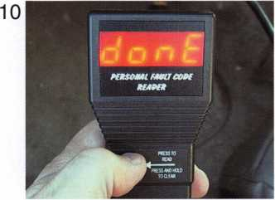

1. Depress the check button on the PCR to see if any other DTC’s are present. (See photograph 8.) Depress the check button until all DTCs have been read and record­ed. (See photograph 9.) When the last DTC has been shown, the PCR displays “DONE.” (See photograph 10.)

Write down all DTCs and report them to your customer.

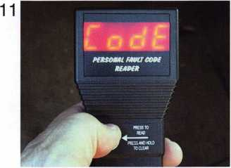

1. The RATTail is also capable of clearing all visible DTCs as well. After making all repairs, simply press and hold the check button to clear DTCs and reset the vehi- clefs computer(s). “CLR” indicates that all codes have been cleared. (See photo­graph 11.)

Make all necessary repairs to vehicle and recheck vehicle for DTCs.

NOTE: In most instances, the vehicle must be operated and complete one or more “OBDII Cycles” before reporting a DTC. These cycles vary by year, manufacturer and model of the vehicle.

|  |  |  |
| --- | --- | --- |
|  | Fault Codes Present | |
| SEQUENCE | LED DISPLAY | STATUS/IDENTICATION |
| 1 | PCR | Introduction/Title message. Press button to proceed. |
| 2 | ... | Logging onto vehicle system |
| 3 | CODE | Checking for fault codes |
| 4 | P | Display a single letter indicating trouble code type: |
|  | C | P-Powe drain  B-Body |
|  | B | C-Chassis |
|  | U | U-Unidentified (for future applications)  This letter is followed by a four-digit trouble code. |
| 5 | NNNN | Four-digit fault number or trouble code. Press button to proceed to step through all present codes.  See sample list of trouble codes |
| 6 | DONE | Operation complete. Press and hold button to clear codes |
| 7 | CLR | Clearing fault codes. |
| 8 | DONE | Operation complete. Press button to re-test. |

|  |  |
| --- | --- |
| Error Troubleshooting Guide (use with code err) | |
| No LED Displayed after plugging into vehicle’s OBDII or Data Link Connector (DLC) port. | 1. Make sure vehicle’s battery is fully charged. 2. Make sure RATTail connector is firmly seated on vehicle’s   OBDII or DLC connector.   1. Make sure ignition lock is in ON position. ACC, LOCK or OFF position will not work. 2. Check fuses. In some instances, power to OBDII port is sup­plied through auxiliary fuses - i.e. cigarette lighter, etc. 3. If after performing steps 1 thru 3 the LED still does not display the DLC terminals that supply power may be damaged. Refer vehicle to dealer for service. |
| Receive constant “Err” message. | 1. Make sure vehicle’s battery is fully charged. 2. Make sure RATTail connector is firmly seated on vehicle’s   OBDII or DLC connector.   1. Make sure vehicle is OBDII compliant - required for 1996+ vehicles. 2. Make sure that the vehicle does not employ CAN technology (starting in some 2004+ vehicles). 3. Newly installed or introduced modules may require an initial­ization process before they are operational. Module initializa­tion is required before the RATTail is able to communicate with the module. If a new or used module was installed, or if modifi­cations were made to existing modules, see authorized dealer for proper initialization procedure. |

Keynotes • November 2003



Generic OBDII Diagnostic Codes

P0100 Mass Air Flow Circuit Maifunction P0101 Mass Air Flow Circuit Range/Performance Problem P0102 MAF Circuit Low Input P0103 MAF Circuit High Input P0104 MAF Circuit Intermittent P0105 MAP/BP Circuit Malfunction P0106 MAP/BP Sensor Range/Performance Problem P0107 MAP/BP Sensor Low Input P0108 MAP/BP Sensor High Input P0109 MAP/BP Circuit Intermittent P0110 IAT Circuit Malfunction P0111 IAT Circuit Range/Performance Problem P0112 IAT Circuit Low Input P0113 IAT Circuit High Input P0114 IAT Circuit Intermittent P0115 ECT Circuit Malfunction P0116 ECT Circuit Range/Performance Problem P0117 ECT Circuit Low Input P0118 ECT Circuit High Input P0119 ECT Intermittent P0120 TP Sensor A Circuit Malfunction P0121 TP Sensor A Circuit Range/Performance Problem P0122 TP Sensor A Circuit Low Input P0123 TP Sensor A Circuit High Input P0124 TP Sensor A Circuit Intermittent P0125 Insufficient Coolant Temp For Closed Loop Fuel Control

P0126 Insufficient Coolant Temp For Stable Operation P0128 Coolant Thermostat Malfunction P0130 Heated 02 Sensor Circuit Malfunction (Bank 1, Sensor 1)

P0131 Heated 02 Circuit Low Voltage (Bank 1, Sensor 1) P0132 Heated 02 Sensor Circuit High Voltage (Bank 1, Sensor 1)

P0133 Heated 02 Sensor Circuit Slow Response (Bank 1, Sensor 1)

P0134 Heated 02 Sensor Circuit No Activity Detected (Bank 1, Sensor 1)

P0135 Heated 02 Sensor Heater Circuit Malfunction (Bank 1, Sensor 1)

P0136 Heated 02 Sensor Circuit Malfunction (Bank 1, Sensor 2)

P0137 Heated 02 Sensor Circuit Low Voltage (Bank 1, Sensor 2)

P0138 Heated 02 Sensor Circuit High Voltage (Bank 1, Sensor 2)

P0139 Heated 02 Sensor Circuit Slow Response (Bank 1, Sensor 2)

P0140 Heated 02 Sensor Circuit No Activity Detected (Bank 1, Sensor 2)

P0141 Heated 02 Sensor Heater Circuit Malfunction (Bank 1, Sensor 2)

P0142 Heated 02 Sensor Circuit Malfunction (Bank 1, Sensor 3)

P0143 Heated 02 Sensor Circuit Low Voltage (Bank 1, Sensor 3)

P0144 Heated 02 Sensor Circuit High Voltage (Bank 1, Sensor 3)

P0145 Heated 02 Sensor Circuit Slow Response (Bank 1, Sensor 3)

P0146 Heated 02 Sensor Circuit No Activity Detected (Bank 1, Sensor 3)

P0147 Heated 02 Sensor Heater Circuit Malfunction (Bank 1, Sensor 3)

P0150 Heated 02 Sensor Circuit Malfunction (Bank 2, Sensor 1)

P0151 Heated 02 Sensor Circuit Low Voltage (Bank 2, Sensor 1)

P0152 Heated 02 Sensor Circuit High Voltage (Bank 2, Sensor 1)

P0153 Heated 02 Sensor Circuit Slow Response (Bank 2, Sensor 1)

P0154 Heated 02 Sensor Circuit No Activity Detected (Bank 2, Sensor 1)

P0155 Heated 02 Sensor Heater Circuit Malfunction (Bank 2, Sensor 1)

P0156 Heated 02 Sensor Circuit Malfunction (Bank 2, Sensor 1)

P0157 Heated 02 Sensor Circuit Low Voltage (Bank 2, Sensor 2)

P0158 Heated 02 Sensor Circuit High Voltage (Bank 2, Sensor 2)

P0159 Heated 02 Sensor Circuit Slow Response (Bank 2, Sensor 2)

P0160 Heated 02 Sensor Circuit No Activity Detected (Bank 2, Sensor 2)

P0161 Heated 02 Sensor Heater Circuit Malfunction (Bank 2, Sensor 2)

P0170 Fuel Trim Malfunction (Bank 1)

P0171 System Too Lean (Bank 1)

P0172 System Too Rich (Bank 1)

P0173 Fuel Trim Malfunction (Bank 2)

P0174 System Too Lean (Bank 2)

P0175 System Too Rich (Bank 2)

P0176 Fuel Composition Sensor Circuit Fault P0177 Fuel Composition Sensor Circuit Range/Performance P0178 Fuel Composition Sensor Circuit Low Input P0179 Fuel Composition Sensor Circuit High Input P0180 Fuel Temperature Sensor A Circuit Malfunction P0181 Fuel Temperature Sensor A Circuit Range/Perfbrmance P0182 Fuel Temperature Sensor A Circuit Low Input P0183 Fuel Temperature Sensor A Circuit High Input P0184 Fuel Temperature Sensor A Circuit Intermittent P0185 Fuel Temperature Sensor B Circuit Malfunction P0186 Fuel Temperature Sensor B Circuit Range/ Performance

P0187 Fuel Temperature Sensor B Circuit Low Input P0188 Fuel Temperature Sensor B Circuit High Input P0189 Fuel Temperature Sensor B Circuit Intermittent P0190 Fuel Rail Pressure Sensor Circuit Malfunction P0191 Fuel Rail Pressure Sensor Circuit Range/Performance P0192 Fuel Rail Pressure Sensor Circuit Low Input P0193 Fuel Rail Pressure Sensor Circuit High Input P0195 Engine Oil Temperature Sensor Circuit Malfunction P0196 Engine Oil Temperature Sensor Range/Performance P0197 Engine Oil Temperature Sensor Low P0198 Engine Oil Temperature Sensor High P0199 Engine Oil Temperature Sensor Intermittent P0200 Injector Circuit Malfunction P0201 Injector Circuit Malfunction - Cylinder #1 P0202 Injector Circuit Malfunction - Cylinder #2 P0203 Injector Circuit Malfunction - Cylinder #3 P0204 Injector Circuit Malfunction - Cylinder #4 P0205 Injector Circuit Malfunction - Cylinder #5 P0206 Injector Circuit Malfunction - Cylinder #6 P0207 Injector Circuit Malfunction - Cylinder #7 P0208 Injector Circuit Malfunction - Cylinder #8 P0209 Injector Circuit Malfunction - Cylinder #9 P0210 Injector Circuit Malfunction - Cylinder #10 P0211 Injector Circuit Malfunction - Cylinder #11 P0212 Injector Circuit Malfunction - Cylinder #12 P0213 Cold Start Injector #1 Malfunction P0214 Cold Start Injector #2 Malfunction P0215 Engine Shutoff Solenoid Malfunction P0216 Injection Timing Control Circuit Malfunction P0217 Engine Overtemp Condition P0218 Transmission Overtemp Condition P0219 Engine Overspeed Condition P0220 Throttle/Pedal Position Sensor/Switch B Circuit Malfunction

P0221 Throttle/Pedal Position Sensor/Switch B Performance Problem

P0222 Throttle Position Sensor B Circuit Low Input P0223 Throttle Position Sensor B Circuit High Input P0224 Throttle Position Sensor B Intermittent P0225 Throttle Position Sensor C Circuit Malfunction P0227 Throttle Position Sensor C Circuit Low Input P0228 Throttle Position Sensor C Circuit High Input P0229 Throttle Position Sensor C Intermittent P0230 Fuel Pump Primary Circuit Malfunction P0231 Fuel Pump Secondary Circuit Low P0232 Fuel Pump Secondary Circuit High P0233 Fuel Pump Secondary Circuit Intermittent P0234 Engine Overboost Condition P0235 Turbocharger Boost Sensor A Circuit Malfunction P0236 Turbocharger Boost Sensor A Performance P0237 Turbocharger Boost Sensor A Circuit Low P0238 Turbocharger Boost Sensor A Circuit High P0239 Turbocharger Boost Sensor B Circuit Malfunction P0240 Turbocharger Boost Sensor B Circuit Range/Performance

P0241 Turbocharger Boost Sensor B Circuit Low P0242 Turbocharger Boost Sensor B Circuit High P0243 Wastegate Solenoid A Malfunction P0244 Wastegate Solenoid A Range/Performance P0245 Wastegate Solenoid A Low P0246 Wastegate Solenoid A High P0247 Wastegate Solenoid B Malfunction P0248 Wastegate Solenoid B Range/Performance P0249 Wastegate Solenoid B Low P0250 Wastegate Solenoid B High P0251 Injection Pump Fuel Metering Control A Malfunction P0252 Injection Pump Fuel Metering Control A Range/Performance

P0253 Injection Pump Fuel Metering Control A Low P0254 Injection Pump Fuel Metering Control A High P0255 Injection Pump Fuel Metering Control A Intermittent P0256 Injection Pump Fuel Metering Control B Malfunction

P0257 Injection Pump Fuel Metering Control B Range/Performance

P0258 Injection Pump Fuel Metering Control B Low P0259 Injection Pump Fuel Metering Control B High P0260 Injection Pump Fuel Metering Control B Intermittent P0261 Injector Circuit Low - Cylinder #1 P0262 Injector Circuit High - Cylinder #1 P0263 Cylinder #1 Balance Fault P0264 Injector Circuit Low - Cylinder #2 P0265 Injector Circuit High - Cylinder #2 P0266 Cylinder #2 Balance Fault P0267 Injector Circuit Low - Cylinder #3 P0268 Injector Circuit High - Cylinder #3 P0269 Cylinder #3 Balance Fault P0270 Injector Circuit Low - Cylinder #4 P0271 Injector Circuit High - Cylinder #4 P0272 Cylinder #4 Balance Fault P0273 Injector Circuit Low - Cylinder #5 P0274 Injector Circuit High - Cylinder #5 P0275 Cylinder #5 Balance Fault P0276 Injector Circuit Low - Cylinder #6 P0277 Injector Circuit High - Cylinder #6 P0278 Cylinder #6 Balance Fault P0279 Injector Circuit Low - Cylinder #7 P0280 Injector Circuit High - Cylinder #7 P0281 Cylinder #7 Balance Fault P0282 Injector Circuit Low - Cylinder #8 P0283 Injector Circuit High - Cylinder #8 P0284 Cylinder #8 Balance Fault P0285 Injector Circuit Low - Cylinder #9 P0286 Injector Circuit High - Cylinder #9 P0287 Cylinder #9 Balance Fault P0288 Injector Circuit Low - Cylinder #10 P0289 Injector Circuit High-Cylinder #10 P0290 Cylinder #10 Balance Fault P0291 Injector Circuit Low - Cylinder #11 P0292 Injector Circuit High - Cylinder #11 P0293 Cylinder #11 Balance Fault P0294 Injector Circuit Low-Cylinder #12 P0295 Injector Circuit High-Cylinder #12 P0296 Cylinder #12 Balance Fault P0300 Random Misfire Detected P0301 Cylinder #1 Misfire Detected P0302 Cylinder #2 Misfire Detected P0303 Cylinder #3 Misfire Detected P0304 Cylinder #4 Misfire Detected P0305 Cylinder #5 Misfire Detected P0306 Cylinder #6 Misfire Detected P0307 Cylinder #7 Misfire Detected P0308 Cylinder #8 Misfire Detected P0309 Cylinder #9 Misfire Detected P0310 Cylinder #10 Misfire Detected P0311 Cylinder #11 Misfire Detected P0312 Cylinder #12 Misfire Detected P0320 Ignition Engine Speed Input Circuit Malfunction P0321 Ignition Engine Speed Input Circuit Range/Performance

P0322 Ignition Engine Speed Input Circuit No Signal P0323 Ignition Engine Speed Input Circuit Intermittent P0325 Knock Sensor 1 Circuit Malfunction P0326 Knock Sensor 1 Circuit Range/Perfbrmance P0327 Knock Sensor 1 Circuit Low Input P0328 Knock Sensor 1 Circuit High Input P0329 Knock Sensor 1 Circuit Intermittent P0330 Knock Sensor 2 Circuit Malfunction P0331 Knock Sensor 2 Circuit Range/Performance P0332 Knock Sensor 2 Circuit Low Input P0333 Knock Sensor 2 Circuit High Input P0334 Knock Sensor 2 Circuit Intermittent P0335 Crankshaft Position Sensor A Circuit Malfunction P0336 Crankshaft Position Sensor A Circuit Range/Perfbrmance

P0337 Crankshaft Position Sensor A Circuit Low Input P0338 Crankshaft Position Sensor A Circuit High Input P0339 Crankshaft Position Sensor A Circuit Intermittent P0340 Camshaft Position Sensor Circuit Malfunction P0341 Camshaft Position Sensor Circuit Performance P0342 Camshaft Position Sensor Circuit Low Input P0343 Camshaft Position Sensor Circuit High Input P0344 Camshaft Position Sensor Circuit Intermittent P0350 Ignition Coil Primary / Secondary Circuit Malfunction P0351 Ignition Coil Primary A / Secondary Circuit Malfunction P0352 Ignition Coil Primary B / Secondary Circuit Malfunction P0353 Ignition Coil Primary C / Secondary Circuit Malfunction P0354 Ignition Coil Primary D / Secondary Circuit Malfunction P0355 Ignition Coil Primary E / Secondary Circuit Malfunction P0356 Ignition Coil Primary F / Secondary Circuit Malfunction P0357 Ignition Coil Primary G / Secondary Circuit Malfunction P0358 Ignition Coil Primary H / Secondary Circuit Malfunction

Keynotes • November 2003

P0359 Ignition Coil Primary I / Secondary Circuit Malfunction P0360 Ignition Coil Primary J / Secondary Circuit Malfunction P0361 Ignition Coil Primary K / Secondary Circuit Malfunction P0362 Ignition Coil Primary L / Secondary Circuit Malfunction P0370 Timing Reference High Resolution Signal A Malfunction P0371 Timing Reference High Resolution Signal A Too Many Pulses

P0372 Timing Reference High Resolution Signal A Too Few Pulses

P0373 Timing Reference High Resolution Signal A Intermittent P0374 Timing Reference High Resolution Signal A No Pulses P0375 Timing Reference High Resolution Signal B Malfunction

P0376 Timing Reference High Resolution Signal B Too Many Pulses

P0377 Timing Reference High Resolution Signal B Too Few Pulses

P0378 Timing Reference High Resolution Signal B Intermittent P0379 Timing Reference High Resolution Signal B No Pulses P0380 Glow Plug Circuit A Malfunction P0381 Glow Plug Indicator Circuit Malfunction P0382 Glow Plug Circuit B Malfunction P0385 Crankshaft Position Sensor B Circuit Malfunction P0386 Crankshaft Position Sensor B Circuit Range/Performance

P0387 Crankshaft Position Sensor B Circuit Low Input P0388 Crankshaft Position Sensor B Circuit High Input P0389 Crankshaft Position Sensor B Circuit Intermittent P0400 EGR Flow Malfunction P0401 EGR Flow Insufficient Detected P0402 EGR Flow Excessive Detected P0403 EGR Circuit Malfunction P0404 EGR Circuit Range/Performance P0405 EGR Sensor A Circuit Low Input P0406 EGR Sensor A Circuit High Input P0407 EGR Sensor B Circuit Low Input P0408 EGR Sensor B Circuit High Input P0410 SAI System Malfunction P0411 SAI System Incorrect Upstream Flow Detected P0412 SAI System Switching Valve A Circuit Malfunction P0413 SAI System Switching Valve A Circuit Open P0414 SAI System Switching Valve A Circuit Shorted P0415 SAI System Switching Valve B Circuit Malfunction P0416 SAI System Switching Valve B Circuit Open P0417 SAI System Switching Valve B Circuit Shorted P0418 SAI System Relay A Circuit Malfunction P0419 SAI System Relay B Circuit Malfunction P0420 Catalyst System Efficiency Below Threshold (Bank 1) P0421 Warm Up Catalyst Efficiency Below Threshold (Bank 1) P0422 Main Catalyst Efficiency Below Threshold (Bank 1) P0423 Heated Catalyst Efficiency Below Threshold (Bank 1) P0424 Heated Catalyst Temperature Below Threshold (Bank D

P0426 Catalyst Temperature Sensor Range/Performance (Bankl)

P0427 Catalyst Temperature Sensor Low Input (Bank 1)

P0428 Catalyst Temperature Sensor High Input (Bank 1) P0430 Catalyst System Efficiency Below Threshold (Bank 2) P0431 Warm Up Catalyst Efficiency Below Threshold (Bank 2) P0432 Main Catalyst Efficiency Below Threshold (Bank 2) P0433 Heated Catalyst Efficiency Below Threshold (Bank 2) P0434 Heated Catalyst Temperature Below Threshold (Bank **2)**

P0436 Catalyst Temperature Sensor Range/Performance (Bank 2)

P0437 Catalyst Temperature Sensor Low Input (Bank 2)

P0438 Catalyst Temperature Sensor High Input (Bank 2) P0440 Evaporative Emission Control System Malfunction P0441 Evaporative Emission Control System Incorrect Purge Flow

P0442 Evaporative Emission Control System Leak Detected P0443 Evap Emission Control System Purge Control Circuit Malf.

P0444 Evap Emission Control Sys Purge Control Valve Circuit Open

P0445 Evap Emission Control Sys Purge Control Valve Circuit Short

P0446 Evap Emission Control System Vent Malfunction P0447 Evap Emission Control System Vent Circuit Open P0448 Evap Emission Control System Vent Circuit Shorted P0449 Evap Emission Control System Vent Circuit Intermittent P0450 Evap Emission Control System Pressure Sensor Malfunction

P0451 Evap Emission Control System Pressure Sensor Performance

P0452 Evap Emission Control System Pressure Sensor Low Input

P0453 Evap Emission Control System Pressure Sensor High Input

P0454 Evap Emission Control System Pressure Sensor Intermittent

P0455 Evap Emission Control System Leak Detected (Gross Leak/No Flow)

P0460 Fuel Level Sensor Circuit Malfunction P0461 Fuel Level Sensor Circuit Range/Performance P0462 Fuel Level Sensor Circuit Low Input P0463 Fuel Level Sensor Circuit High Input P0464 Fuel Level Sensor Circuit Intermittent P0465 Purge Flow Sensor Circuit Malfunction P0466 Purge Flow Sensor Circuit Range/Performance P0467 Purge Flow Sensor Circuit Low Input P0468 Purge Flow Sensor Circuit High Input P0469 Purge Flow Sensor Circuit Intermittent P0470 Exhaust Pressure Sensor Circuit Malfunction P0471 Exhaust Pressure Sensor Circuit Range/Performance P0472 Exhaust Pressure Sensor Low P0473 Exhaust Pressure Sensor High P0474 Exhaust Pressure Sensor Intermittent P0475 Exhaust Pressure Control Valve Malfunction P0476 Exhaust Pressure Control Valve Performance P0477 Exhaust Pressure Control Valve Low P0478 Exhaust Pressure Control Valve High P0479 Exhaust Pressure Control Valve Intermittent P0480 Cooling Fan 1 Control Circuit Malfunction P0481 Cooling Fan 2 Control Circuit Malfunction P0482 Cooling Fan 3 Control Circuit Malfunction P0483 Cooling Fan Rationality Check Malfunction P**0484** Cooling Fan Circuit Over Current P0485 Cooling Fan Power/Ground Circuit Malfunction P0500 Vehicle Speed Sensor Malfunction P0501 Vehicle Speed Sensor Range/Performance P0502 Vehicle Speed Sensor Low Input P0503 Vehicle Speed Sensor Intermittent P0505 Idle Air Control System Malfunction P0506 Idle Air Control System RPM Lower Than Expected P0507 Idle Air Control System RPM Higher Than Expected P0510 Closed Throttle Position Switch Malfunction P0520 Engine Oil Pressure Sensor/Switch Circuit Malfunction P0521 Engine Oil Pressure Sensor/Switch Circuit Range/Performance

P0522 Engine Oil Pressure Sensor/Switch Circuit Low Input P0523 Engine Oil Pressure Sensor/Switch Circuit High Input P0530 A/C Refrigerant Pressure Sensor Circuit Malfunction P0531 A/C Refrigerant Pressure Sensor Circuit Range/Performance

P0532 A/C Refrigerant Pressure Sensor Circuit Low Input P0533 A/C Refrigerant Pressure Sensor Circuit High Input P0534 A/C Refrigerant Charge Loss P0550 Power Steering Pressure Sensor Circuit Malfunction P0551 Power Steering Pressure Sensor Circuit Range/Performance

P0552 Power Steering Pressure Sensor Circuit Low Input P0553 Power Steering Pressure Sensor Circuit High Input P0554 Power Steering Pressure Sensor Circuit Intermittent P0560 System Voltage Malfunction P0561 System Voltage Unstable P0562 System Voltage Low P0563 System Voltage High P0565 Cruise ON Signal Malfunction P0566 Cruise OFF Signal Malfunction P0567 Cruise RESUME Signal Malfunction P0568 Cruise SET Signal Malfunction P0569 Cruise COAST Signal Malfunction P0570 Cruise ACCEL Signal Malfunction P0571 Cruise Brake Switch Circuit Malfunction P0572 Cruise Brake Switch Circuit Low P0573 Cruise Brake Switch Circuit High P0600 Serial Communications Link Malfunction P0601 Internal Control Module Memory Check Sum Error P0602 Control Module Programming Error P0603 Powertrain Control Module KAM Test Error P0604 Powertrain Control Module RAM Test Error P0605 Powertrain Control Module ROM Test Error P0606 PCM Processor Fault P0608 PCM VSS Output A Malfunction P0609 PCM VSS Output B Malfunction P0620 Generator Control Circuit Malfunction P0621 Generator Lamp "L" Control Circuit Malfunction P0622 Generator Field "F" Control Circuit Malfunction P0650 MIL Control Circuit Malfunction P0700 Transmission Control System Malfunction P0701 Transmission Control System Range/Performance P0702 Transmission Control System Electrical P0703 Brake Switch Input Malfunction P0704 Clutch Switch Input Circuit Malfunction P0705 Transmission Range Sensor Circuit Malfunction P0706 Transmission Range Sensor Circuit Range/Performance

P0707 Transmission Range Sensor Circuit Low Input P0708 Transmission Range Sensor Circuit High Input P0709 Transmission Range Sensor Circuit Intermittent P0710 Transmission Fluid Temperature Sensor Circuit Malfunction

P0711 Transmission Fluid Temperature Sensor Circuit Range/Perf

P0712 Transmission Fluid Temp Sensor Circuit Low Input P0713 Transmission Fluid Temp Sensor Circuit High Input P0714 Transmission Fluid Temp Sensor Circuit Intermittent P0715 Turbine Speed Sensor Circuit Malfunction P0716 Turbine Speed Sensor Circuit Range/Performance P0717 Turbine Speed Sensor Circuit No Signal P0718 Turbine Speed Sensor Circuit Intermittent P0719 Torque Converter/Brake Switch B Circuit Low P0720 Output Shaft Speed Sensor Circuit Malfunction P0721 Output Shaft Speed Sensor No Performance P0722 Output Shaft Speed Sensor No Signal P0723 Output Shaft Speed Sensor Intermittent P0724 Torque Converter/Brake Switch B Circuit High P0725 Engine Speed Input Circuit Malfunction P0726 Engine Speed Input Circuit Range/Performance P0727 Engine Speed Input Circuit No Signal P0728 Engine Speed Input Circuit Intermittent P0730 Incorrect Gear Ratio P0731 Gear 1 Incorrect Ratio P0732 Gear 2 Incorrect Ratio P0733 Gear 3 Incorrect Ratio P0734 Gear 4 Incorrect Ratio P0735 Gear 5 Incorrect Ratio P0736 Reverse Incorrect Ratio P0740 Torque Converter Clutch Circuit Malfunction P0741 Torque Converter Clutch System Performance Or Stuck Off

P0742 Torque Converter Clutch Circuit Stuck On P0743 Torque Converter Clutch System Electrical P0744 Torque Converter Clutch Circuit Intermittent P0745 Pressure Control Solenoid A Malfunction P0746 Pressure Control Solenoid A Performance or Stuck Off P0747 Pressure Control Solenoid A Stuck On P0748 Pressure Control Solenoid A Electrical P0749 Pressure Control Solenoid A Intermittent P0750 Shift Solenoid A Malfunction P0751 Shift Solenoid A Performance P0752 Shift Solenoid A Stuck On P0753 Shift Solenoid A Electrical P0754 Shift Solenoid A Intermittent P0755 Shift Solenoid B Malfunction P0756 Shift Solenoid B Performance P0757 Shift Solenoid B Stuck On P0758 Shift Solenoid B Electrical P0759 Shift Solenoid B Intermittent P0760 Shift Solenoid C Malfunction P0761 Shift Solenoid C Performance P0762 Shift Solenoid C Stuck On P0763 Shift Solenoid C Electrical P0764 Shift Solenoid C Intermittent P0765 Shift Solenoid D Malfunction P0766 Shift Solenoid D Performance P0767 Shift Solenoid D Stuck On P0768 Shift Solenoid D Electrical P0769 Shift Solenoid D Intermittent P0770 Shift Solenoid E Malfunction P0771 Shift Solenoid E Performance P0772 Shift Solenoid E Stuck On P0773 Shift Solenoid E Electrical P0774 Shift Solenoid E Intermittent P0775 Pressure Control Solenoid B Malfunction P0776 Pressure Control Solenoid B Performance P0777 Pressure Control Solenoid B Stuck On P0778 Pressure Control Solenoid B Electrical P0779 Pressure Control Solenoid B Intermittent P0780 Shift Malfunction P0781 1 - 2 Shift Error

P0782 2 - 3 Shift Error P0783 3 - 4 Shift Error P0784 4 - 5 Shift Error P0785 Shift/Timing Solenoid Malfunction P0786 Shift/Timing Solenoid Range/Performance P0787 Shift/Timing Solenoid Low P0788 Shift/Timing Solenoid High P0789 Shift/Timing Solenoid Intermittent P0790 Mode Switch Circuit Malfunction P0801 Reverse Inhibit Control Circuit Malfunction P0803 1 - 4 Upshift (Skip Shift) Solenoid Circuit Malfunction P0804 1 - 4 Upshift (Skip Shift) Lamp Control Circuit Malfunction

Keynotes • November 2003

21

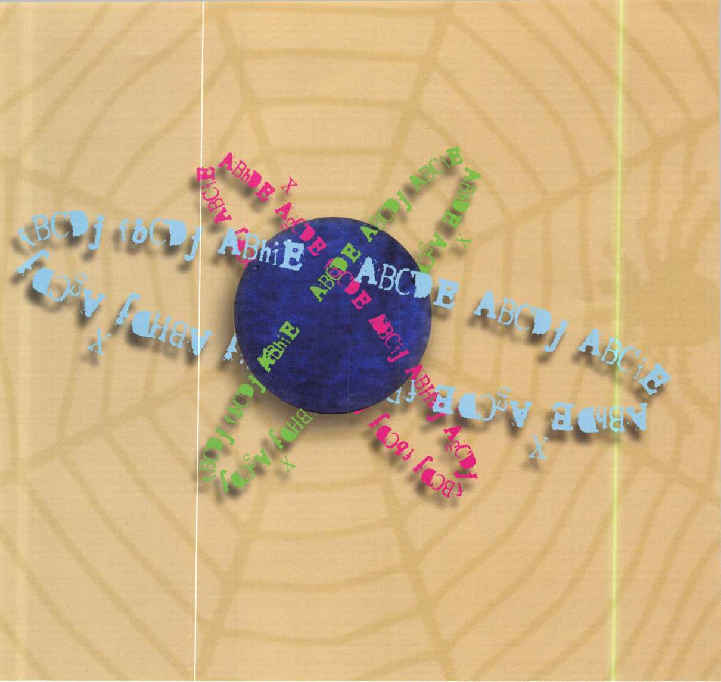

The Magic of Spherical Master Keying

By Eric Costley, CRL



Keynotes • November 2003

There are a few things about master keying that regularly tend to make me cringe. Customers often want certain areas cross keyed, which immediately puts a glitch in your mathematical progression. Cross keying normally requires you to either stack master pins in a chamber or leave certain pin chambers totally empty, and both of these methods wreak havoc on my gastrointestinal system.

I despise either, and generally spend a great deal of time trying to explain to the end user that cross keying is, at best, not only difficult, but inadvisable.

Even so, I occasionally find myself eventually succumbing to a customer’s very specific desires.

The most common of these requests is that each key within the system work the exterior doors. I always advise against this, since any key in the system that might be lost or stolen becomes a compromise — not only to the exterior doors, but interior areas as well — and the entire system should be rekeyed in such an instance. A separate key, requiring most end users to carry two keys, is far more secure. Also, since most exterior doors open outward, end users have a tendency to use the key to pull the door open, causing undue stress on the cylin­ders and keys.

Were it not for the required master key, cross keying an exterior door is a simple maison problem. For instance, a five-pin cylinder with one master pin in each chamber yields 32 possible keys that operate the cylinder. The following chart illustrates this, and by using letters instead of numbers, allows you to plug in your own information. This will also help later on, as we begin to delve into master keying, and examine the “sphere” effect.

Our exterior cylinder is pinned to two distinct keys: ABODE, and fghij. The resulting bottom pins are ABODE, and the master pins fghij. The use of upper and lowercase letters will help illustrate a pattern that becomes immediately obvious. The 32 keys that operate this cylinder are listed in Chart A.

As you examine the 32 keys that we have generated, you’ll notice the divided groupings represent the degree of variation from our original key, ABODE. If we pin any given cylinder only to its individual bitting, no other key will operate it, yet all 32 keys will work in our exterior door cylinder, which only has one master pin in each chamber.

Now, let’s add some spice to the recipe! I’m going to make ABODE the master key in this system. If we pin all these locks so that ABODE will fit, plus each individual key, we get 32 cylinders that fall into an interesting hierarchy. For instance, a cylinder pinned to key 32 and the master is our original cylinder, fit by all keys in the system. A cylinder pinned to key 11 and the master is now fit by keys 1,3,4, and 11. Extrapolating this further, we find that key 11 will now also fit cylinders pinned to keys 17, 20, 21, 27, 28, 31 and 32. Basically, with only two variables in any given pin chamber, we have created a maze of masters and cross keys. What we have here is a simple type of rotating constant master key system, limited in size, but incredibly flexible! For example, a cylinder pinned to key 30 can be operated by keys 22 and 24. But cylinders pinned to key 22 and 24 remain autonomous, so we have a built-in cross key! (Of course, the 30 cylinder could also be operated by keys 1,2,4,5,6,8,9,10, 14,15,16,25 and 26 — if you choose to use them.)

ABODE

ABCDj

ABCil

**abode**

fBCDE

ABCij

1.

**2**.

3.

4.

5.

**6**.

7.

8.

1. ABCDj
2. fBCDj
3. ABhiE
4. ABCiE
5. fBCiE
6. AShDE
7. fBhDE
8. fBCDE
9. ABhij
10. AsCij
11. IBCij
12. ABhiE
13. fBhiE
14. fBhDE
15. fBCiE
16. fsCDj
17. IBhDj
18. ABhDj
19. ABhij
20. fBhij
21. fBCij
22. IBhDj
23. fBhiE
24. fBhij

Keynotes • November 2003

In our theo-

retical sys-  
tem, key  
one

becomes  
the great  
great grand  
master.

Keys 2  
through 6  
become  
great

grand mas-

ters, keys 7  
through 16 become

grand masters, keys

17 to 26 become mas-  
ters, and keys 27 to 31

become the lowest level of change keys,  
which only operate their specific area and our number  
32 cylinder, which is operated by all keys in the sys-  
tem. The fun in this system arises because cross keys,  
as well as master keys, arise simultaneously and spo-  
radically in the hierarchy. Consequently, key 32 would  
operate only the exterior door.

A diagram of the interrelationships between the keys in this system yields a spherical hierarchy, with our master, ABCDE, at the north pole and our exterior door key, fghij, at the south pole.

Now, for the sake of complicating things further, let’s look at the wildest extreme. With our existing master key, number 1, let’s turn the whole thing upside down and create another master key from the other end of the system. Now key 32 is a second great great grand master. Under this system, keys 27 through 31 become great grand masters, keys 17 through 26 become grand masters, keys 7 through 16 become masters, and keys 2 through 6 become the pawns. What we have created here is a spherical system, with autonomous mas- terkeys at both poles and a veritable hornet’s nest of submasters, interchanges, and still the option for any key in the system to operate our original exterior door cylinder.

By using both our original keys, (ABCDE and fghij,) as masterkeys we can create a system that has great grand masters at either end, and 2 groups of 10 keys whose variation from either pole of the sphere depends on how the cylinder is keyed. Herein is the beauty of the system: A cylinder keyed to ABhiE,

(key 11,) can be set up in a variety of ways. We can key it to key 11 only, or master it to either key 1 or 32. If the cylinder is keyed only to key 11, it will still work our exterior door cylinder, yet it is no longer part of the master key system. Such a situation would be ideal for areas that require an outside agent, such as a deliv­ery or utility service, to gain access to areas that no one else in the building is allowed. This process of turning off and on masterkeys is called “selective master keying.” Using both ends of the sphere can also be useful in a situation where offices and manu­facturing areas require separate access with limited interchange. For example, the office master key could be key 1, and the plant master key could be key 32. Certain areas can be cross-keyed so that the plant manager could have access to certain offices, while selected office staff could also gain access to particular areas in the manufacturing area. An owner would be required to carry only two keys to access all areas! Using both ends of the system is not recommended, however, since incidental interchange is rampant in this system. The use of both poles as masters is rec­ommended only when the sphere (and master key system) is divided equally at the “equator,” or halfway point.

I would love to be able to draw a nice diagram of this system for you, which would visually illustrate the complexity and relationships between keys and cylin­ders, but it is virtually impossible to do in two dimen­sions. At best, I am able to only list such information, which I will attempt later on in this article. What I really need to diagram this is one of those fancy sets of balls and sticks that you might remember from High School, which we used to diagram the construc­tion of various molecules. Ofes, it really is that complex!)

“It is a spider web of cross keying done with no possibility of key interchange . **A.J. Hoffman**



Keynotes • November 2003



Primarily, we will only tackle the sphere from the north pole down. The reason for this is that working from the south pole upwards requires different pin­ning for each of the respective cylinders, and it is unlikely and inadvisable that you would use both ends of the sphere simultaneously It is enough to know that the possibility exists, should you desire to attempt it. In addition, the relationships are identical from either end of the pole, depending upon how any given cylinder is pinned.

There are, of course, severe limitations to this system. The system inherently can only accommodate 32 keys, and using even most of them is virtually impossible without creating an unintended interchange. If you were to expand this to a six-pin system, you double the size to 64 keys, which gives you at least a bit more room to maneuver. Primarily, this system is most use­ful when a limited number of keys and cylinders are needed. A system that I recently implemented needed only 7 keys and the master, and only 9 keying varia­tions. The beauty of the system is that the exterior doors were no less secure than a full position progres­sion, and all of the interior doors (including those that were cross keyed) had less than a full compliment of master pins!

Here is the listing of cylinders and the keys that fit them, from the north pole down. Hopefully, this will help you at some point in your attempt to satisfy a demanding customer, without compromising your own integrity as a professional.

One last note: I am indebted to Robert F. Thomas, CML, who initially sparked my interest in the possi­bility of such a system years ago by cutting all 32 keys that fit a cylinder keyed to two distinct keys. I have wrestled with this concept at various times since then, but only recently found a practical application for this theoretical system. It truly was a case of necessity being the mother of invention. I am also indebted to A. J. Hoffman, CML, Laurence Simon, CML, Jerome Andrews, CML, Bruce Cary, CML, and of course, my brother, Brian Costley, CML, CMST, for their review of my rough draft.

For those of you who might still be scratching your heads, perhaps instead of thinking in terms of letters, think of this as a binary system. In any given pin posi­tion, there are only two choices. What spherical key­ing boils down to is a mix of maison, rotating con­

stant, and binary systems all neatly boiled down into a small package. A.J. Hoffman, CML, said it best, I think, when he struck a personal nerve: “It’s a spider web of cross keying done with no possibility of key interchange.” Thanks, A.J., for the spider reference. Bruce Carey, CML, also noted that “I should get this patented.” My personal feeling about that is that I should share it, so that those of you in the field can satisfy a customer without a great deal of grief. All the credit I need is the fact that I help some poor guy who is trying to satisfy a demanding customer.

Anyone who desires a headache can extrapolate this to six or seven pin systems. My hope is that someone will take the time to carry this idea to its extreme. Perhaps some industry people who have access to computer programmers can make us a nice diagram of this, and make it feasible for all of us to use. Fve done my best with the limited time and abilities I have.

And so, then, to all of you: Happy spherical keying!

Now, with oat funner delay, is the proedsed RsUeg. Good luck!

A NIMBI uhnsd to key 1: Is operated by those KEYS:

uni Mi

M2 Msl,2

M3 Ms 1,3

M4 Ms 1,4

M5 MSI,5

M6 MS 1,6

Ml Keys 1,2,3,7

M3 HOIS 1.2,4,8

M9 Keys 1,2,5,9

M10 MS 1,2,6,10

MU Keys 1,3,4.11

M12 Roys 1,3,5,12

M13 Keys 1,3,6,13

M14 Keys 1,4,5,14

M15 MS 1,4,6,15

M16 MS 1,5,6,16

Mil MS 1,2,3,4.7.6.11,11

M18 Keys 1,2,3,5,7,9,12.16

M19 MS 1,2,3,6,7,16,13,19

M 20 MS 1,3,4,5,11,12.14.20

M 21 Keys 1,3,4,6,11,13.15.21

M 22 MS 1,4,5.6.14.15.16.22

M23 MS 1,3,5,6,12,13,16,23

M24 MS 1,2,5,6,9,10,16,24

M25 MS 1,2,4,6,6.16.15.25

M26 Keys 1,2,4,5,6,9,14,26

M 27 MS 1,2,3,4,5,7,0.9,11,12.14,17.16,26,26,27

M 29 MS 1,2,3,4,6,7,0.10,11.13.15.17,19,2125.26

M 29 Keys 1,2,3,5,6,7,9,10,12.13.16.16,19.23.24,29

M 30 Keys 1,2,4,5,6,6,9,10.14.15.16.22.24.25.26.36

M 81 Keys 1,3.4,5.6,11.12.13,14,15.16.20.21.22,23,31

M32 All Keys within tke systeer



Keynotes • November 2003

A Pair of Gun Safes

By Greg Perry, CML, CPS

This month, we’ll look at a couple of gun safes — one  
Liberty and one Amsec that looks more like a Sentry,  
especially inside. The pictures of the Liberty came  
during a combination change. It’s not all that special,  
but it does have an interesting relock trip mechanism.  
The Amsec is their offering of an inexpensive gun  
safe. These pictures came after I used the

process of elimination to open  
it.

Looking at  
the Liberty  
gun safe, you’ll  
notice it’s a

handgun or home  
safe. It’s only  
30X24X20 (inches)  
deep. The basic

design is similar to its  
larger brothers. The

lock is a 6741, and has an  
interesting spring around

one of the screws holding  
the back cover and relock  
plate to it. I used a bit of  
Locktite on the threads of

both screws. It made me a little nervous to install the  
screw without any Locktite. The other one has a large  
plastic washer under the screw head. The spring of  
the relock is quite heavy, making it very difficult to  
lift from the outside. The location of the relock is 2  
inches right of the lock centerline. Another interest-  
ing thing about this design is the bolt detent and  
hinge side locking. The door slips behind the frame as  
it is locked, and the frame has a plate that slips into  
the door to trip the bolt detent. Most manufacturers  
design the bolt detent rod to trip outside the door.

The second safe — an Amsec — is an inexpensive gun safe, model number 5924. Amsec gun safes traditional­ly have used a quality mechanical lock or electronic

lock from one of the major lock manufacturers. This  
safe looks similar to a gun safe made by Sentry. I  
asked Bob Sallee from Amsec about the similarities;  
they import the formed steel body and the door from  
overseas. Once the raw body and door are at their fac-  
tory, they paint and assemble the safes with a lock,

which they also import. Amsec called us to

open the safe. The customer had

the safe delivered, locked

it and the com-

bination on  
the card was  
wrong. I veri-

fied the serial  
number to the

combination sup-  
plied from the fac-

tory and the combi-  
nation card both had

the same numbers for  
the combination. The

customer indicated he  
thought something seemed

strange when the last num-  
ber on the card (18) didn’t

match the number on the dial  
(35) before he locked it. I applied a little pressure on  
the wheel pack with the handle. Turning the dial  
revealed 10 gates (or should I say nine false gates and  
one real gate?). The number he remembered had a  
gate wider than the false gates. Using the number 35  
as the last number, I started the process of elimina-  
tion to open the safe. A short time later, the safe  
was open.

Let me explain the process of elimination. I first saw it explained by Dave McOmie in an article published in The National Locksmith. Start with a number, in this case I dialed right three times to zero for the first number, knowing this style of lock requires at least a 10 number difference I dialed left 2 times to 10. Next

Keynotes • November 2003

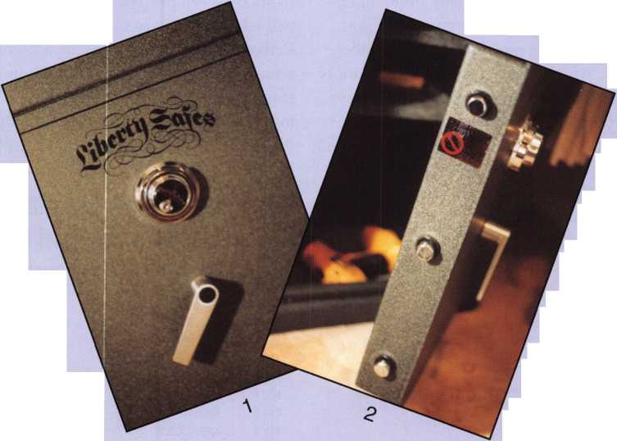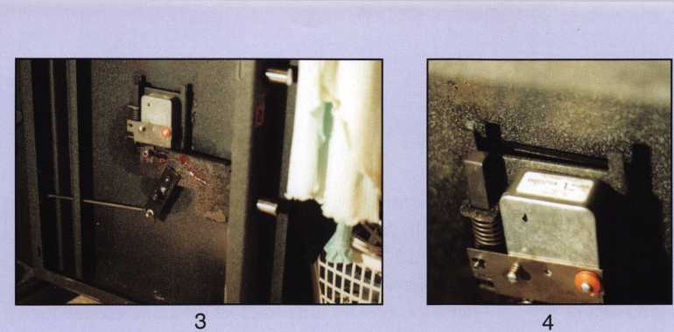

I turned back to 35 and tested the handle. Since this didn’t work, I turned the dial left to 15 then back right to 35. I continued this process until I reached 90. Since none of these numbers opened the safe I incremented the first number to 5 and started the process over again. Since the last number was 35, I skipped testing the numbers 30, 35 and 40 for the second digit. (Remember all the numbers must be at least 10 digits apart.) This may seem like it takes a lot of time, but this time, the first number turned out to be 70, and only took about 20 minutes. Dialing all the possibilities might have taken 30 minutes, less time than drilling and repair. I spent more time removing the back cover, taking pictures and reassembling the safe.

Amsec recommended drilling the safe through the dial 7/8-inches down at 50. This allows you to dial the combination using the hole to look at the two wheels, and then the drive cam. This method requires you to turn the dial to a number, then move the dial back to line the hole in the dial up with the hole in the safe. A hole anywhere below the 2 V2-inch diameter wheels would allow you to scope the combination.

The downside to drilling especially outside the dial ring is repair. Gun safes usually have nice paint jobs that are very difficult to match. Opening safes using the process of elimination saves time and, although it doesn’t require any special skill, it makes you look like a magician to the customer.

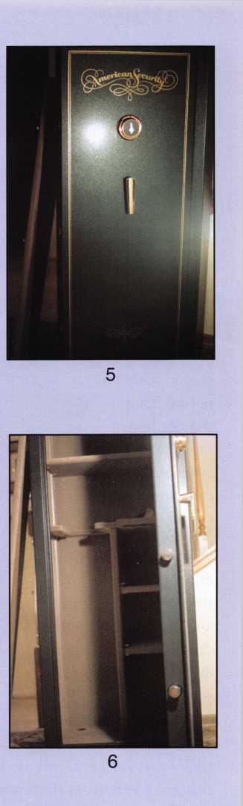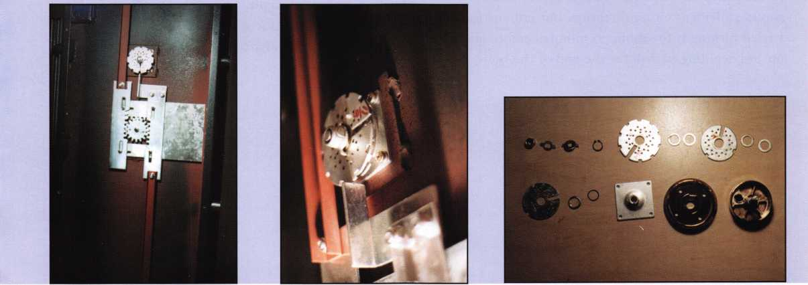

7

8

9

Kevnotes • November 2003

**2**

Hamilton Night Depository

By Greg Perry CML, CPS

Safe openings come in all shapes and sizes. The vast  
majority of my openings are pretty easy This one was  
not! Over two hours of drilling; first I had to get past  
a ball bearing and then a carbide mix that required a  
diamond-core drill. This call was a referral, one of  
their alarm technicians spent five hours on Monday  
trying to coax the S&G 6120 electronic

lock open, to no avail. The key-

pad beeped, but the

motor made no  
noises. They  
did not have a  
safecracker  
available, so the  
call came to me.

I started by remov-  
ing the keypad to drill  
down the spindle hole  
through the lock case

and motor. This method  
can be tricky; the idea is  
drill into the motor and  
spin the armature. I used a  
hole saw, available from

Northwest Safe and Vault. The  
tricky part is to not drill too deep. In my case, I  
snagged a wire from the armature. Not a good idea;  
this kept the motor from turning. I could turn it  
about 45 degrees either direction, but not any further.  
I tried turning it for about 30 minutes before giving  
up and deciding to drill for the end of the bolt.

Using a Mini-Rig template from LA Safe & Vault for  
the Kaba Mas X-07 and X-08 lock, I selected hole  
“B,” which is for the bolt. Fve found that many tem-  
plates have hole locations that are close or offer the  
same location for different locks that are useable for  
other locks. The same template, hole “C” can be used  
for a scope hole when drilling an S&G

6700 series lock. The 1 V2-inch of

mild steel drilled easily,

then I hit my

first obstacle,  
a ball bearing.  
This time, as

you can see in  
the picture, the

ball bearing is on  
the edge of the

hole. Breaking out a  
Ball-Buster bit from

StrongArm, I inserted a  
wood plug included in

the package and used a  
punch to smash it into the

hole. This stabilizes the ball  
bearing and allows the bit,

which is a carbide burr to  
grind or “chew” the edge of the bearing. The tech-  
nique to use with the Ball-Buster is to tighten the drill  
chuck snug, but not tight. The idea is to allow the bit  
to spin in the chuck if it grabs in the hole. This will  
prevent the bit from shattering. Once past the bear-  
ing, I tried to switch to a carbide bit. The bearing

Keynotes • November 2003

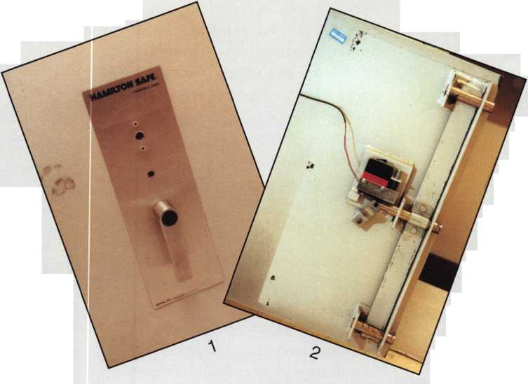

**MEMBERSHIP APPLICATION**



Welcome to the Associated Locksmiths of America, Inc., an association for persons involved in the security industry as  
locksmiths, security consultants, educators, manufacturers and distributors.

To apply for membership, please complete this application and submit it with the dues for the current year, and your  
business card, company letterhead, or other suitable proof of employment.

All of the following questions MUST be answered before this application may be processed. Please type or print.

TYPE OF MEMBERSHIP

Please check only one.

* ACTIVE MEMBERSHIP Individuals actively engaged in supplying, servicing, or installing security hardware for a period of not less than two years.
* APPRENTICE MEMBERSHIP Individuals who are in initial train­ing and meet all the requirements for Active Membership except for the length of time in the security industry.
* ALLIED MEMBERSHIP Individuals whose position in the security industry relates to the aims, policies and promotion of the locksmith and his/her craft.

APPLICATION AND FEES

A $50 application fee, appropriate annual dues, and your business card, company letterhead, or suit­able proof of employment must accompany this application. Your second year's dues will be prorated based on the date your application was received by ALOA.

CANDIDATE (PLEASE TYPE OR PRINT)

FINAL CHECKLIST

□ Application Fee

U.S.

Dollars

50.00

ANNUAL DUES STRUCTURE

* Active/Allied Member 155.00 U.S. + U.S. Territories

(PR, VI, Guam)

* Active/Allied Member 1 30.00 Non U.S. Resident or

Non U.S. Territories

* Apprentice Member 80.00

U.S. and International

OTHER FEES

* Canadian Air Mail 20.00
* Overseas Air Mail 50.00

Total Enclosed

**Return to**

**ALOA**

**3003 Live Oak Street  
Dallas, TX 75204-6185  
(214)827-1701**

|  |  |  |  |
| --- | --- | --- | --- |
| Name □ Mr. □ Mrs. □ Ms. | | | |
| Business Name | | | |
| Mailing Address | | | |
| City | State | Zip Code | Country |
| Work Phone | Home Phone |  | Fax |
| Email Address | Website |  |  |
| Date of Birth | Social Security Number |  |  |
| Directory Address (if different than mailing address) | | | |
| City | State | Zip Code | Country |

□ Do Not List in Directory

PROFESSIONAL INFORMATION

1. Are you a...

* Sole Owner □ Corporate Officer
* Partner □ Employee □ Student

1. Are you currently employed in the security industry?

* no □ yes, years

1. How did you learn locksmithing or security work?

4. ALOA Sponsor

Sponsors ALOA Number

Please note, if you are sponsored by an ALOA member, your application will be immediately processed with a 90-day probation period. Otherwise, final processing takes up to 120 days.

5. Names and addresses of two industryrelat- ed references (required):

*Name*

Address

Name

Address

6. IMPORTANT: Have you ever been convicted of a felony? □ No □ Yes

If yes, please give details on a separate sheet. All felonies are reported to the Membership Department for review.

METHOD OF PAYMENT

□ Check □ MasterCard □ Visa □ Discover □ American Express

|  |  |
| --- | --- |
| Card Number | Expiration Date |
| Please print name as it appears on card |  |

Cardholder's Signature

I certify that all statements are true and, if accepted as a member, I agree to abide by the rules, regulations, and Bylaws of ALOA, and further agree to adopt the Code of Ethics of ALOA as my own, and adhere to it to the best of my ability. Should my membership be discontinued, I agree to return my mem­bership card, and cease use of all ALOA insignia.

Signature

Date

Revised 1 2/03

5

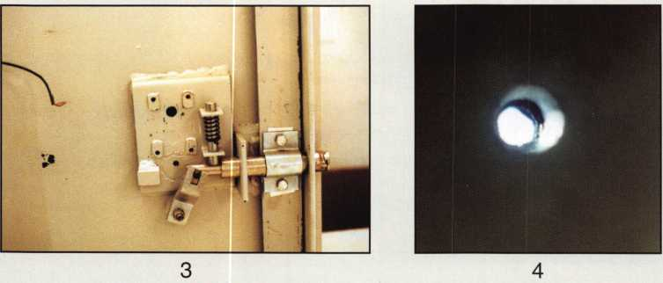

**I**

would spin on the flutes of the bit and grab. I tried to insert another plug but the bearing kept spinning. I slowly made a little progress into the hardplate behind the ball bearing hardplate, then stopped. Looking in the hole with a scope, I could see a piece of carbide. I was now about an hour into drilling this safe. The Brinks driver was there for the pickup and the safe was still locked. Could he come back later?

I chucked up a diamond core drill and inserted it into the hole. The diamond would not go past the bearing. The Ball-Buster is slightly smaller than the diamond core drill. This meant the hole would need to be enlarged. I enlarged the outer hole to 5/i6” and chucked the Ball-Buster snugly into my drill chuck. Slowly, I ground the edge of the bearing, enlarging the hole until I could get the diamond core drill past the

bearing. Once I started drilling with the diamond core drill, it progressed quickly. Once the hole was though the hardplate, I removed the Mini-rig and plate. Reaching in with a probe, I lifted the bolt and turned the handle, somewhat anti-climatic. The Brinks driver showed up about 30 minutes after I got the safe open.

This safe opening presented more challenges than I normally face. I routinely open GSA Red label con­tainers requiring diamond-core drilling, and occasion­ally have run into a ball bearing hardplate, but this was the first safe I’ve drilled requiring both. It wasn’t easy. I would have preferred to not be under such a time crunch, but having the right equipment and training ahead paid off this time. Hamilton built one tough safe!

**THE HINGE DOCTOR**

*Corrects Door  
Sagging by  
Straightening  
Bent Hinges*

* **Slip Tool Over Hinge**
* **Open Door**
* **Presto! It's That Easy!**
* **Door Is Fixed.**

*An Easy Tool Which Will Add Profits  
To Any Locksmith's Arsenal*

**— GKL Products —**

**800924-5397**

**[www.hinqedoctor.com](http://www.hinqedoctor.com)**

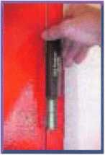

Keynotes • November 2003

**Renew or Apply for Membership ONLINE at [www.aloa.org](http://www.aloa.org)**

**During times of crisis, unity is key. Right now, when you join ALOA  
(or renew your membership), you will receive, free of charge,  
this patriotic decal for your shop or van, which serves as a  
special reminder to you and your customers that it takes  
a spirited effort to strengthen the ties that bind us.**

**HLUH locksmiths m**

Secure America v*.

**Decal dimensions 8y2" x 5'//**

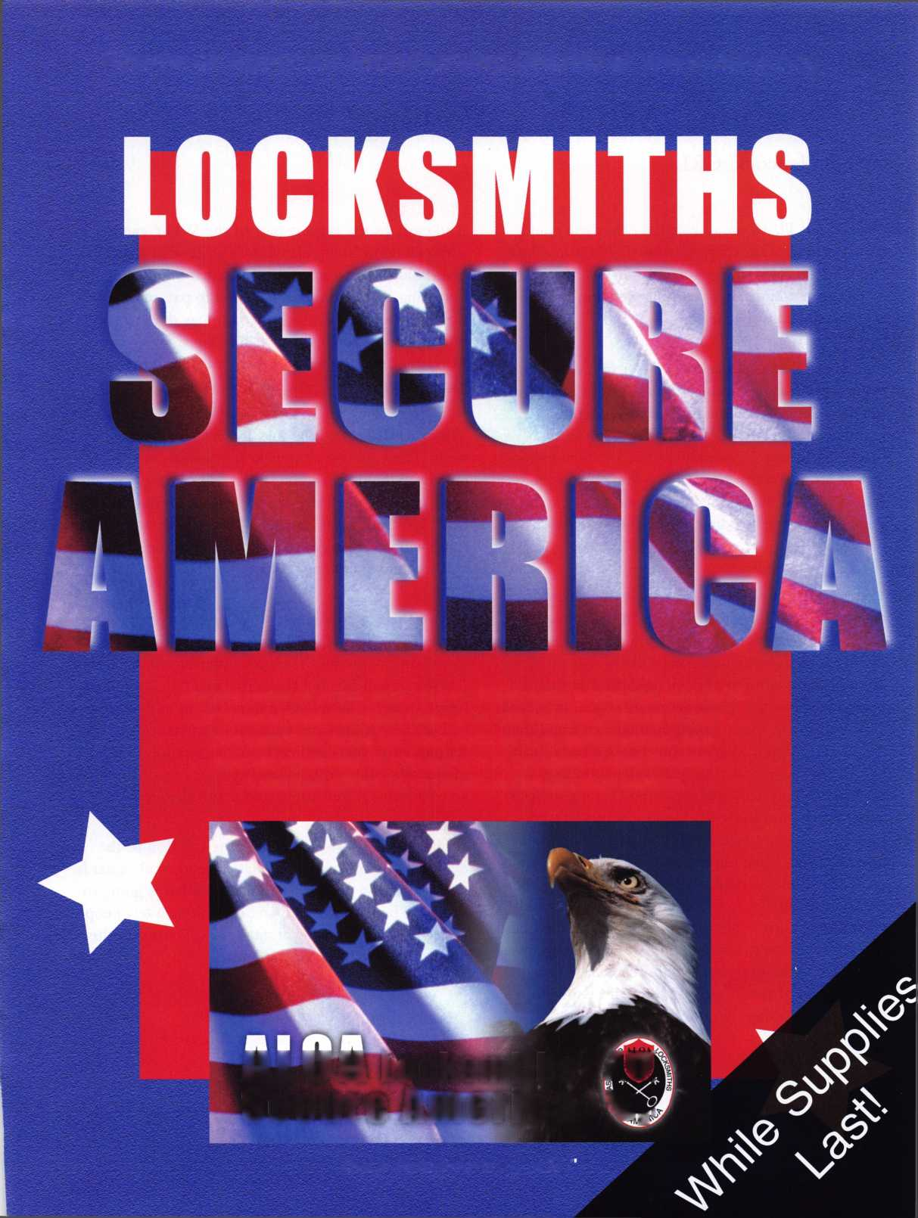

OPINION

Associations: Are They Working?

By Jim Hancock, CRL

Yes and no. That’s the only answer that you could realistically give for this question. There is no black and white answer any longer, only shades of gray. For some organizations, it is working well. For others, it seems to be a lost battle.

One of the perks of teaching classes for ALOA and other organizations is the ability to travel around and see how things are going for the smaller state or regional organizations. What I have seen in the majority of these is a steady decline in membership as well as attendance at the classes. The obvious ques­tion is why? What is causing this and what can be done to stop the bleeding before the association bleeds out.

The why of this question is perhaps the easiest to answer and the toughest to solve. In many instances, the why is because of transgressions past. Many ex­members of these associations will say that the associ­ation became more of a social organization than a betterment of the profession organization. It became a forum for the seated board members to wield their power and impose their will on the membership. It became less about sharing knowledge, bonding together to halt bad legislation and keeping undesir­ables out of our industry and more about let’s get together once or twice a year and partake of adult beverages and trash our competition and so on and so on. These same ex-members will say they quit renew­ing their membership because they had a personal grievance against a member or members of the board and chose not to support them. And more important­ly, these ex-members would tell prospective new members all of the negatives about the association thereby persuading them not to join.

And perhaps the biggest part of the WHY can be summed up in a very elementary statement that I’ve heard more than a few times; What is being a mem­ber going to do for me? Do I need to pay an organiza­tion to socialize? No. Do I need to pay dues to trash talk and hold grudges? No. Is missing a day or two of work to attend a seminar, clinic or trade show going to be worth my time and possible loss of income?

There are other reasons that I’ve heard expressed as well. “There are never any classes close to me, they are always held across the state,” “They never get any­body good to teach the classes, it’s always old Bob and he’s a locksmith just like me,” “The classes are always so expensive.” You get the picture. Truth be told, you and I helped paint the picture.

Any of this sound familiar? Ever said any of these things yourself? I have. I am as guilty of these profes­sional sins as anyone. The only difference may be that I woke up and smelled the coffee and chickory (it’s a Cajun thing). I have been a member off and on of sev­eral of the national and local associations for the bet­ter part of 37 years and each and every time I have let my membership lapse, it has been for one of the myri­ad of reasons stated above and many unstated.

So what is the answer? What is the solution to the dwindling membership and class attendance? What is the association going to do for me? What is going to bring me back to the fold and drag along a few people with me? The following are just my opinions on this, but it is maybe food for thought.



Keynotes • November 2003

First, lets address the education issue. To me, this is perhaps the biggest and most important reason to belong. Without education, you will become stagnant in your business and be of little use to your clientele. Whether ALOA supplies an instructor, a manufactur­er supplies an instructor or it’s just “old Bill,” there is always something to be learned. I understand the mentality because I have kids. When my son was growing up, I could give him advice until I was blue in the face and it never registered. Let a total stranger come along and tell him the exact same thing and he would run with it. The message was the same, just the delivery service was different. Give ‘old Bill5 a chance to give you some pointers and insight.

reason or another. About every 6 weeks, we are put­ting on “road shows.” We are putting on classes on a weekend in the remote parts of the state for members and non-members alike and the best part of this is we have received assistance from several distributors, whom I won’t name here for fear they will get inun­dated with calls, in the form of sponsorship money and materials so that these road show classes are free or almost free to members. Sorry, non-members still pay a little more here as well. Perhaps an incentive to join. Because of this proactive approach to education, we feel our membership will increase because some of the nay-sayers will see that this is no longer the “good old boy association” that it may have once been.

As for the clinics, classes and such being to far away or expensive, I can only tell you what we are trying to do in the Texas and Louisiana-Mississippi associa­tions. First we are thinking about centralizing our

Another page we have taken from the ALOA blue­print is offering incentives for members to recruit new members. These incentives can be anything from discounted education and dues to free tickets to the

Without education, you will become stagnant  
in your business and be of little use

to your clientele. j

yearly Convention and Trade Shows in a location not only geographically advantageous for all but in a loca­tion that allows easy air travel for prospective vendors and instructors. Consensus opinion seems to be that if you know where and when the big event is to be held every year, it will be easier to plan ahead enough to be able to attend. In Texas, TLA is setting pricing up for the classes at the convention to reflect mem­bership. In other words, long time continuous mem­bers receive a price break over short time members who receive a break over non-members. We have started the package pricing idea of classes. Charging not per class but rather per day. (thank you ALOA) Take what you want on any given day, the price is the same. And the more days you take, the less expensive it becomes. We are also addressing those folks in the outlying areas of the state that can’t attend for one

association banquet. Just a small spiff to say thanks and we appreciate your efforts.

You may be saying “OK, it all sounds good and feasi­ble, but what about licensing. How can my local asso­ciation help me with something as powerful as my state’s legislature and the lobbyists from the special interest groups that have their ears.” Well first, licensing is inevitable. Get over that fact first and foremost. Those states which do not have it yet, will soon enough. The difference will be whether you let it get enacted with or without representation. ALOA tries its best to watchdog the different sessions in each state for pending legislation but it should be up to each state association to protect its own yard. You, as an individual, have very little chance of getting all the info needed and even less of a chance as a solo

Keynotes • November 2003

Licensing is inevitable.

States which do not have it yet, will.  
The difference will be whether  
you allow it to be enacted  
with or without representation.

voice of being heard. Everyone is in concurrence that the driving force behind the legislation is the Alarm industry If that is the case, do you think the one guy that owns AAA Alarm company went in by himself and had his state pass the law because it’s what he wanted? Absolutely not. He went in with the entire State Burglar and Fire Alarm Association behind him to get it done. Regardless of whether it is money or favoritism that makes it happen, the bottom line is the number of members these groups have. Could any state organization or perhaps even ALOA match up with that type of backing? Probably not. And neither the state nor national association can match up when its membership roster continues to decline meaning that the money needed to fight bad laws isn’t there. Also, once legislation does pass (and it will) who directs how the licensing will be instituted and admin­istered? Who regulates the criteria for the license? Is it a fluff license all about money or will it actually mean something? Will there be testing and continuing education? Can you alone help make any of these decisions or affect any changes? Probably not. It will only be as part of a larger group that change may be effected. That larger group needs to be your local association and certainly ALOA.

Now, some of you in New Jersey or Philadelphia may be wondering how big a problem this is, getting peo­ple to show up and support their state organization. Lord love you guys because you always seem to have a full house at your conventions but let me give you a

couple of examples of how bad it is. I made a 1400 mile round trip for a two-day interchangeable core class which was attended by 3 people. That was 3 peo­ple. Another organization had a spring board meeting and classes a year or so ago and could not even get a quorum of board members to hold the meeting. The class was attended by 5 people, 3 of which were board members.

The time to stop the bleeding is now. It’s time to stop procrastinating, get off your rear ends and help strengthen all of our trade associations by belonging, getting involved and getting others involved. So many times the complaint is that the same 8 or 10 people always seem to run the state organization year after year. Maybe it’s because that’s the only 8 or 10 people willing to give of themselves to help keep the local association going. If you aren’t particularly fond of your current leadership or think you have a better idea, quit complaining and become part of the solu­tion by getting on the local board. Don’t be just another part of the problem.

And while you’re at it, do not neglect ALOA. They could use your help and support as much as the local associations.

I’ve said my piece. If I have offended anyone, my apologies. But if I have offended you, perhaps it was you I was speaking to.

Keynotes • November 2003

Proue Vou’re a Pro ’04

HLOH Rewards Its Members HGHINM

The RLOR Membership Campaign for 2004 features  
more member benefits than we’ue euer offered

before. LUe’re stuffing members full of great gifts!!

If gou renew gour commitment to gour industrg  
and help support RLOR, we will offer FREE mem-  
bership dues to RNV CURRENT MEMBER who  
recruits one new member on or before Januarg  
1, 2004.

HLOH is excited about the uast legislatiue challenges that lie ahead,

and we re waiting for our members to let us after those groups that  
are aiming to legislate locksmiths out of business, one bad bill at a

time. LUe're readg to do our part for the prosperitg of this industry.

Please help yourselues by doing your part this year. Proue you’re a pro by

sticking with HLOH in 2004. Vou will be rewarded for it many times ouer.

Note: The HLOH Board of Directors has enacted a $25 Legislatiue assessment to the regular HLOH dues for all actiue members in the USH (and territories) in 2004. If you Hue in the United States or its territories, you must pay the assessment to maintain your membership. The assessment will be payable during this year s dues billing, which mailed on Oct. 1, 2005. Hs directed specifically in writing by the HLOH Board, the proceeds from this assessment will be auailable for use ONLV in BLOB's legislatiue efforts.

**Rll members Luho renew on or before January 1, 2004, will receiue:**

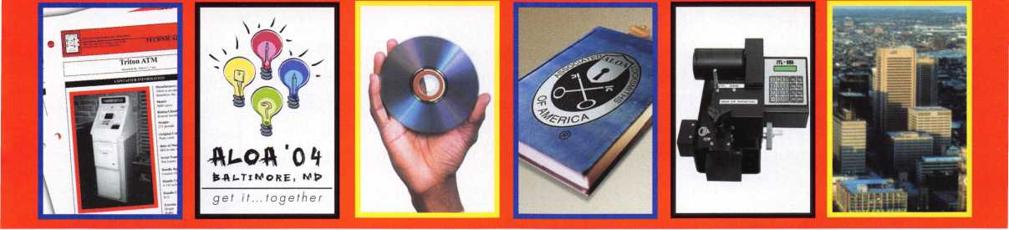

R complimentary set  
of 2 safe technical  
bulletins

Up to $300 sauings  
on RLOR 2004  
Conuention  
registration

R complimentary  
copy of the RLOR  
Membership  
Directory (CD)

R $10 discount for any purchase from the RLOR Bookstore

Rutomatic entry into  
a drawing for a  
brand new ITL-950C  
key code machine



Associated Locksmiths of America

3003 Liue Oak Street • Dallas, Texas 75204-6186

800-532-ALOA (2562) • ioioui.aloa.org

Automatic entry into  
a drawing for a free  
RLOR 2004  
Conuention Full  
Registration  
Package (including  
hotel)



The New Face of

SCHWAB

Founded in 1872 in Lafayette, Indiana, Schwab Safe Company

is one of Indiana’s oldest continuously operational manufacturers.

The Schwab Safe Company’s early credits include vault doors

and safes, baby buggies and horse drawn carriages, as well as a

wide range of castings.

ytt

*$q0*

Today, Schwab manufactures a complete line of fire resist-  
ant products which include: vault and file room doors, fire-  
Qd o proof filing cabinets, contemporary media and record cabi-  
nets, and safes for the architectural, industrial and residen-

tial markets worldwide. Schwab continues to deliver high

^cj t ? ^ ^ ^ quality products that have made the Schwab name syn

0-

^ ^onymous with the highest craftsmanship and depend-

v-tir+j. .-'k'A

^ ^ ft*

ability for more than 131 years.

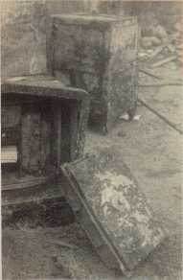

\9#

**50S**\*01

Schwab, under new ownership strives to remain on  
■*'r 1 the cutting edge of technology while maintaining the  
+■ highest manufacturing standards. We are releasing  
revolutionary designs, and incorporating state-of-  
the-art manufacturing technology just 10 months  
after the acquisition, with many improvements  
in our product line as well as big plans for an  
exciting new year. With a solid foundation,

Schwab Corp. is committed to maintain name recognition  
in the marketplace as the #1 fire protective equipment manufacturer  
in the world.

Schwab’s leadership in manufacturing with NFPA 232- Protection of Records Standard  
and a UL Class 133 Standard ratings lends it to be on the forefront of innovative ideas and  
product design. With the computer age upon us, Schwab manufactures a wide variety of stor-

age products that meet the stringent heat and humidity requirements of  
computer media protection as well as paper record protective products.

Schwab safe 1930

**\* 1**f

**Sr ‘321 |**

Schwab **Safe Col**

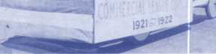

In 1921, Bill Kennedy made a decision that would influence the rest of his life. He decided to take a job at Schwab because the Company had the best baseball team in the commercial league. As the photo­graph indicates, they were called l he Bats”. The team had won the championship in 1921 and 1922 and was looking forward to another victory in 1923.

Evidently baseball was not the only thing Bill Kennedy liked about Schwab, he remained employed at Schwab for the next 34 years, retir­ing on January 31, 1975.

Schwab’s Vault Door, available in variable fire resistant ratings up to 6 hours

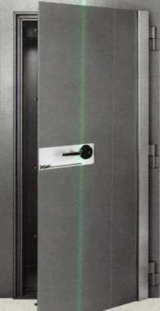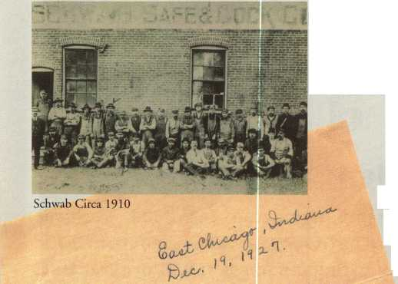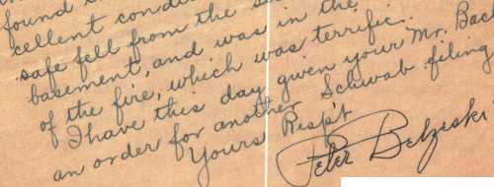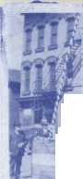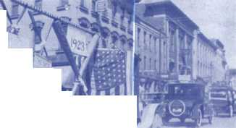

Schwabs record cabinet carries a UL rating of 350-1 Hr. fire and impact resist-  
ance rating, with six models and an unlimited number of interior accessory  
options available. The media cabinet carries a UL 125-1 Hr. rating as to fire and  
impact resistance and humidity level not to exceed 80%, and also has many inte-  
rior options available to suit your specific media storage needs. Schwabs media

and record cabinet has all the protection of a safe with a stylish design, suitable  
for todays elegant and contemporary office or home office environment. With

many interior options to choose from, the Schwab cabinet can be customized to

suit any and all of ones storage needs while not detracting from the aesthetics of  
your environment. Please call 1-800-447-7233 or visit [www.schwabcorp.com](http://www.schwabcorp.com) to  
request our most current literature.

Schwab Safe Models 4068 and 2532 CTS

Schwabs Vault and File Room Door, with up to Class  
350-6 Hr. UL fire ratings, comes with two UL relocking

devices and can be made to accomodate a range of walls 7-18

inches thick with easy non-grout installation and complies with NFPA Life Safety Code.  
Standard with a Group II Key Change combination lock, safe is also equipped with an

inside escape mechanism. Schwab also has plans to reintroduce a Class 5-6 security

door for additional protection.

On January 1, 2003, Schwab Corp. was acquired by two private  
investors. As a result of the acquisition, the Company has been recapi-  
talized to allow for a period of growth. The new manage-

ment team has a proven record in manufacturing and

product design. We are very excited about the future

of the Company and look forward to combining

innovative ideas with a very experienced and devot-

ed workforce. The rebirth of Schwab Corp. with focus on customer service and support,

has prompted us to make communicating with us easier. Complete with extended hours and

a toll free number devoted to technical service, Schwab is concentrating on making it a pleas-

ure to do business with us. With our vast product line, we have introduced new sales tools, which  
include a Floor Plan Agreement, where the dealers may purchase a floor display model for their showrooms, with  
a delayed 0% interest payment option. Complete with a new website, new literature, and extended hours, we  
feel our sales force will soon be the best equipped in the marketplace.

We are committed to our customers, suppliers and associates to become the industry standard in providing the

highest quality products and customer service. For a complete product  
listing visit our website, or contact us at the number below.

SCHWABCORR

Fire protection for vital records."

P.O. Box 5088 • Lafayette, IN 47903-5088  
800-447-7233 • [www.schwabcorp.com](http://www.schwabcorp.com)

4 stages of fire testing circa 1930. You will note the Schwab safe is still standing in picture 4.

‘The Boys”-1930 before testing the safe (pictures left).

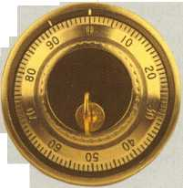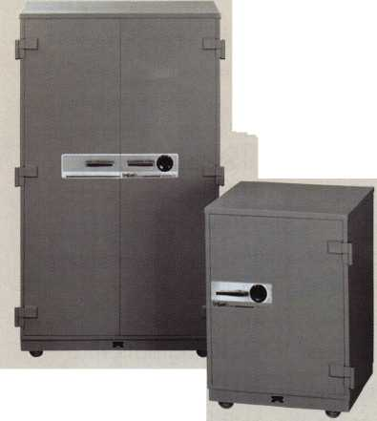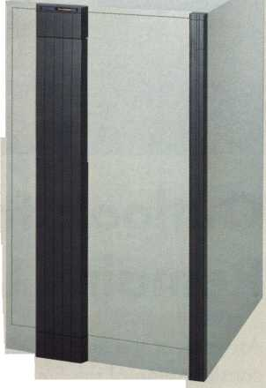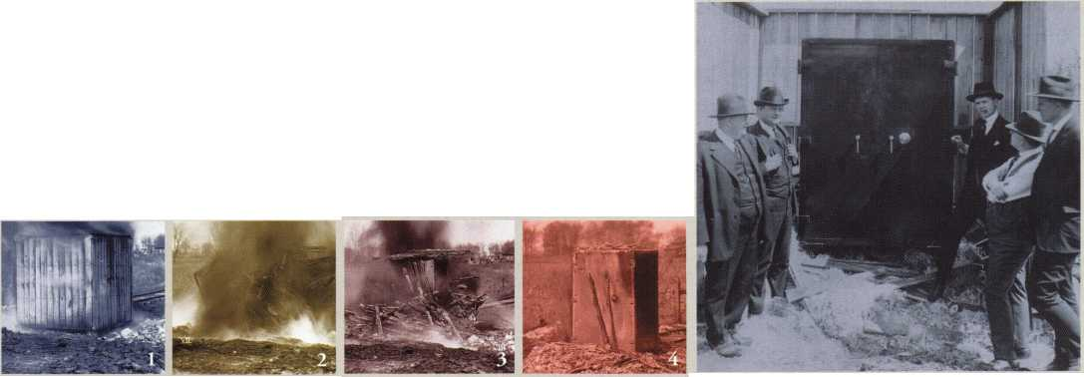

g i s I a t i v e  
date

Outlook for AHP Legislation in Senate Remains Uncertain

As we near the end of October, the outlook for consideration of the Small Business Health Fairness Act of 2003 (S. 545) in the Senate remains highly uncertain. Since Congress recon­vened after Labor Day, the primary focus of both the House and the Senate has been finaliz­ing the 13 Appropriations bills that fund the fed­eral budget for fiscal year 2004, Medicare pre­scription drug legislation, comprehensive energy legislation (which has become urgent in the wake of the August blackout), and the Iraq/Afghanistan Supplemental Appropriations bill. At this time, it is unclear how long Congress will remain in session this year, and thus what issues will receive consideration.

As Congress returned from its summer recess, President Bush promoted his support for the AHP legislation at a speech in Kansas City, Missouri in early September. The AHP legisla­tion was included in the President's "Six Point Plan for the Economy" as an essential compo­nent of "Making Health Care Costs More Affordable and Predictable." Helping small and medium-sized businesses control their health care costs will allow those employers to create new jobs more quickly, and thus the President saw fit to include the AHP legislation in his eco­nomic package.

Senator Olympia Snowe (R-ME) issued a press release on September 9 calling on the Senate to take up and approve S. 545 as soon as possi­ble. She cited new information on health premi­um increases provided by the Kaiser Family Foundations 2003 "Annual Employer Health Benefits Survey" as evidence of the need for swift Senate action on AHPs. The Kaiser survey, which found double-digit health premium increases for the third consecutive year, clearly demonstrates the need for AHP legislation.

One development that may help to grab the Senateis attention on the AHP bill is the release of new numbers of uninsured Americans by the U.S. Census Bureau. In 2002, the number of uninsured reached 43.574 million persons, an increase of nearly 2.4 million persons from 2001. The number of people covered by employment-based coverage dropped from 62.6% in 2001 to 61.3% in 2002, and of course this erosion of coverage is most severe among small businesses. These disturbing num­bers will hopefully help us convince undecided Senators that bold action, including the AHP, is needed to reverse the trend of declining cover­age in America.

Both Senator Snowe and Senator Jim Talent (R- MO) issued press releases noting this disturbing

Keynotes • November 2003

trend and urging the Senate to approve the AHP legislation in order to address this problem The AHP is currently pending before the Senate Health, Education, Labor and Pensions (HELP) Committee, which is chaired by Senator Judd Gregg (R-NH). Senator Gregg has not yet taken a position on the AHP legislation, and it will be necessary for him to be supportive if the com­mittee is going to approve the bill and send it to the full Senate for a vote. According to his staff, Chairman Gregg has "serious policy concerns" with the AHP bill, including concerns with adverse selection and the potential impact on the insurance markets of small states like New Hampshire. Of the other members of the Senate HELP Committee, only Senator Kit Bond (R-MO) has cosponsored the bill.

Chairman Gregg's staff has indicated that he intends to hold one or more hearings on "health reform" issues sometime this fall. This would present a good opportunity to get greater con­sideration of the AHP bill by Senators on this key committee should any such hearing(s) be scheduled.

In order to impress upon key Senators, such as Chairman Gregg and Senate Majority Leader Bill Frist (R-TN), that the Senate needs to act on the AHP bill, it is critical to gain the support of more Senators (especially Senators on the HELP Committee). The best way to show progress in this regard is to get more Senators to cosponsor the bill.

Legislative Updates:

Small Business Health Fairness Act (Association Health Plans): Has passed the House (as it has done in previous legislative sessions) and is now awaiting a vote from the Senate. Senator Olympia Snowe (R-ME) is spearheading the charge and hopes to get the bill on the Senate floor shortly. ALOA & our Washington DC based coalition are monitoring the situation closely.

FCC Fax Regulations: The FCC has temporarily withdrawn all of the changes it had planned to implement. We are a member of a coalition run by the American Society of Association Executives (ASAE) and are working hard to make sure that the right changes are made dur­ing this time period

Motor Vehicles Right to Repair Act: HR 2735 is up to 69 Co-Sponsors! This bill is really gaining a lot of momentum. There is a strong chance it will come up for a vote soon.

State Houses: New legislative sessions are just a few months away. ALOA has begun targeting a few select states such as Tennessee and Connecticut as places where we will focus our proactive licensing efforts. We are confident that past hurdles in these areas can be cleared.

We are also closely monitoring regulation processes in Alabama, Texas and Louisiana to ensure that all definitions and interpretations are beneficial to locksmiths.

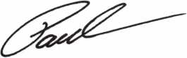

Paul Kanitra • Government Relations Manager

Keynotes • November 2003



EMPLOYMENT

FKI SECURITY GROUP SEEKS QUALIFIED  
TECHNICIANS FOR NEW FIELD  
SERVICE DIVISION

In response to continuing and growing demand for  
field service, FKI Security Group has established the  
FKI Field Services division to support NKL Cash  
Handling products and is seeking qualified techni-  
cians in major metro markets. Technicians will sup-  
port business development and new service contracts  
for NKL Cash Handling, which include electronic bill-  
counters or validators, dispensing safes and access  
control safes. Each field technician will be equipped  
with a state of the art communications system and all  
the necessary parts and tools to service all of FKIis  
security products.

The markets currently open are, Baltimore/  
Washington DC, New Jersey/Metro New York,  
North/Central Ohio, Dallas, Houston,  
Orlando/Central Florida, Northern California,  
Sacramento/East Bay, Southern California, Phoenix

Highly competitive compensation and a complete  
benefits package including health, dental, and vision  
insurance, 401 K plan, and fully paid expenses will  
be offered to qualified technicians. Technicians with  
the experience servicing safes, locks, ATMs or POS  
systems will be considered. This position can grow  
into a management position as the division expands.

Interested parties should contact Christina Lyell at  
800-457-2424 or e-mail your resume to  
[chrisl@fkisecuritygroup.com](mailto:chrisl@fkisecuritygroup.com)"

FKI

SECURITY GROUP

101 Security Parkway

New Albany, IN 47150

STOP LOOKING!!!!!

EXPERIENCED TECHNICIANS WANTED

Lock into your future now! If you are experienced, intelligent, and desire a secure future, come join our team. We are a full service commercial/residential security service (locks, keys, safes, CCTV, access con­trol, door related hardware). We offer: top wages, company vehicle, 401k, paid vacation, paid holi­days, new uniforms, cross training, and job satisfac­tion. We are looking for the best techs who are ready to be treated and compensated as professionals.

Bass Security Services, Inc.

Ph#216-755-1200 ex.#128

Fax#216-755-1220

E-MAIL / [rmesnick@bass-security.com](mailto:rmesnick@bass-security.com)

TURD i©

WHOLESALE SERVICE

**800-848-9790**

**One Call Gets You...**

**Amsec, Gardall  
Hayman, Meilink  
Victor, Winchester**

**Plus Free Delivery  
From America's  
Largest Inventory  
of Safes.**

WANTED TO BUY/SELL

FOR SALE

Original Schlage blanks in 5-pin EF keyway or 6-pin in CE, EF, FG or G keyway at $12.50 per box of 50. Contact George Thomas at 21 8-724-3416 or write to 825 Woodlandd Ave., Duluth MN 55812-2168

WHOLESALE SAFE DEPOSIT LOCKS

Allied, Diebold, Herrin, Hall & Mavin, llco, Lefabure, Mosler, Precission, S&G, Security Corp., Yale. Locks from early 1900s to current. Call or email for lock type and pricing sheet. Quantity discounts. Call WBI at (954)484-2404 or email: [sales@wbi.us](mailto:sales@wbi.us)

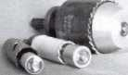

Hole Saw

Alignment

Guides

No More Plywood, "C” Gumps, or Jigs  
Needed to Over Bore Existing Holes

* Our Guides let you over bore existing holes  
  that meas. 5/8”, 3/4" & 1-1/2" diameter
* They work on wood as well as metal
* IWo small sizes ideal for desks and cabinets
* Purchase in sets or individually
* Visa, MC, Amex, Discover
* MONEY-BACK GUARANTEE

Daniel D. Mello, Owner-Locksmith

Groveland, CA

209 962 4692 • 209 962 4910 FAX  
E-mail: [slmello@mlode.com](mailto:slmello@mlode.com)  
 **[www.tricitylock.com](http://www.tricitylock.com)**

BUSINESS FOR SALE

BUSINESS FOR SALE

A small, quite successful business for sale in south Orange County, California. Three Rytan machines, three HPC code machines, HPC code books, coding program, tools for "luxu­ry" vehicle lockouts - all parts, tools and sup­plies to keep two trucks on the road full time. One truck on the road provides $10-1 IK per month. Truck, which is the Ford F250 van with advertising signage, built-in work areas and cabinetry - can be part of the package or pur­chased separately. Low operating costs after 10 years of building the business. Advertising expenses 10 years ago? $4K per month. Now we pay a fifth of that. This is a nice set-up for someone to step in and take over. Existing accounts (which bring in about $8200/month include three in property management and eight auto dealerships. Well work to set you up with our existing accounts. All reasonable offers will be considered. Call 949/370- 9619, or fax 949/458-1733.



Keynotes • November 2003



MOBILE LOCKSMITH BUSINESS FOR SALE Speedex duplicator, van, tools, code books, two HPC code machines (Blitz), inventory, some hardware. $6000 (firm). Call 601/916-6448.

LOCKSMITH FRANCHISE AVAILABLE

Low cost, complete training, national Franchise call (925) 260-7373 [www.SpeedyLocksmiths.com](http://www.SpeedyLocksmiths.com) .

Business For Sale

Classified Advertising Policy

Classified advertising space is provided free of charge to ALOA members, and fora fee of $.60 per word, $ 15 mini­mum for non-members. Classified ads may be used to advertise used merchandise and overstocked items for sale, "wanted to buy" items, business opportunities, employment opportunities/positions wanted and the like. Members or non-members wishing to advertise services or new mer­chandise for sale may purchase a "Commercial Classified Ad," for a fee of $1.30 per word, with a minimum of $40. Each ad will run for Iwo issues. For blind boxes there is a $5 charge to members and non-members. All ads must be submitted in writing to the ALOA office by the fifteenth of the month, two months prior to issue date. Send to Keynotes Classifieds, 3003 Live Oak St., Dallas TX 75204- 6186. ALOA reserves the right to refuse any classified advertisement that it deems inappropriate according to the stated purpose of the classified advertising section.

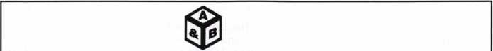

SAFE CORPORATION

MANUFACTURES OF QUALITY DEPOSITORY SAFES AND CHESTS

DISTRIBUTING FROM WAREHOUSES IN

* LOS ANGLES, CA
* CHICAGO, IL
* GLASSBORO, NJ

A & B is now a stocking distributor

for Mutual Safes

featuring

AB-4-30-3S AB-9-2 WS 10-2

Chose from over 75 models in stock

We ship your order within

24 hours

See us

*at [www.a-bsafecorp.com](http://www.a-bsafecorp.com)*800-253-1267  
Fax 856-863-1208

CALL FOR YOUR  
CATALOG TODAY

Keynotes • November 2003

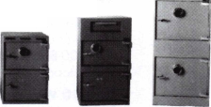

Distributor

ADI Inc

Phone: 631-692-1000 Fax: 631-692-3011

Accredited Lock Supply Co

Phone: 201-865-5015 Fax: 201-865-0030 [www.acclock.com](http://www.acclock.com)

Ace Lock & Security Supply

Phone: 908-688-7666 Fax: 908-688-2442 [www.acelock.com](http://www.acelock.com)

Andrews Wholesale Lock Supply

Phone: 717-272-7422 Fax: 717-274-8659 [www.andrewslock.com](http://www.andrewslock.com)

Boyle & Chase Inc

Phone: 800-325-2530 Fax: 800-205-3500 [www.boyleandchase.com](http://www.boyleandchase.com)

Chinrose International

Phone: 503-357-7553 Fax: 503-357-5522 [www.chinrose.com](http://www.chinrose.com)

Clark Security Products

Phone: 800-854-2088 Fax: 619-974-5284 [www.clarksecurity.com](http://www.clarksecurity.com)

Cook's Building Specialties

Phone: 505-883-5701 Fax: 505-883-5704

Dire's Lock & Key Company

Phone: 303-294-0176 Fax: 303-294-0198

Direct Security Supply, Inc.

Phone: 800-252-5757 Fax: 800-452-8600

Doyle Security Products

Phone: 800-333-6953 Fax: 612-521-0166 [www.doylesecurity.com](http://www.doylesecurity.com)

Dugmore and Duncan, Inc.

Phone: 888-384-6673 Fax: 888-329-3846

E. L. Reinhardt Co., Inc.

Phone: 800-328-1311 Fax: 651-481-0166 [www.elreinhardt.com](http://www.elreinhardt.com)

Ewert Wholesale Hardware

Phone: 800-451-0200 Fax: 708-597-0881

Fairway Supply, Inc.

Phone: 214-350-0021 Fax: 214-352-4299 [www.fairwaysupply.com](http://www.fairwaysupply.com)

Foley-Belsaw Company

Phone: 800-821-3452 Fax: 816-483-5010 [www.foley-belsaw.com](http://www.foley-belsaw.com)

Fried Brothers Inc.

Phone: 800-523-2924 Fax: 215-592-1255 [www.fbisecurity.com](http://www.fbisecurity.com)

H L Flake Co

Phone: 800-231-4105 Fax: 713-926-3399 [www.hlflake.com](http://www.hlflake.com)

H.S. & S. Wholesale Distrib.

Phone: 313-342-6777 Fax: 313-342-7580

Hans Johnsen Company

Phone: 214-879-1550 Fax: 214-879-1530 [www.hjc.com](http://www.hjc.com)

Hardware Agencies, Ltd.

Phone:416-462-1921

[www.hardwareagencies.com](http://www.hardwareagencies.com)

IDN Incorporated

Phone: 817-421-5470 Fax: 817-421-5468 [www.idn-inc.com](http://www.idn-inc.com)

Intermountain Lock & Supply

Phone: 800-453-5386 Fax: 801-485-7205 [www.intermountainlock.com](http://www.intermountainlock.com)

Jo Van Distributors

Phone: 416-752-2238 Fax: 416-752-7282 [www.jovanlock.com](http://www.jovanlock.com)

KeylessRide

Phone: 877-619-3136 Fax: 409-216-5058 [www.keylessride.com](http://www.keylessride.com)

Lockmasters, Inc.

Phone: 859-885-6041 Fax: 859-885-7093 [www.lockmasters.com](http://www.lockmasters.com)

Locks Company

Phone: 800-288-0801 Fax: 305-949-3619

Locksmith Ledger International

Phone: 770-886-0800 Fax: 770-889-7703 [www.lledger.com](http://www.lledger.com)

M. Zion Company

Phone: 212-349-8677 Fax: 212-964-0495 [www.mzion.com](http://www.mzion.com)

McDonald Dash Locksmith Supp

Phone: 800-238-7541 Fax: 901-366-0005 [www.mcdonalddash.com](http://www.mcdonalddash.com)

McManus Locksmith Supply, In

Phone: 704-333-9112 Fax: 704-332-8664

Monaco Lock Co.

Phone: 800-526-6094 Fax: 800-845-5625 [www.monacolock.com](http://www.monacolock.com)

Omaha Wholesale Hardware

Phone: 800-238-4566 Fax: 402-444-1664 [www.omahawh.com](http://www.omahawh.com)

Phoenix Safe International LLC

Phone: 765-483-0954 Fax: 765-483-0962 [www.phoenixsafeusa.com](http://www.phoenixsafeusa.com)

Professional Business Products

Phone: 248-360-3979

Fax: 248-360-3982

[www.professionalbusinessproducts](http://www.professionalbusinessproducts).

RA-Lock Company

Phone: 972-775-6301 Fax: 972-775-6316 [www.ralock.com](http://www.ralock.com)

S J Hope Products

Phone: 702-260-7645 Fax: 702-837-1465

SNA Inc.

Phone: 678-206-0381 Fax: 678-206-0382 [www.sungil-safe.com](http://www.sungil-safe.com)

SecureRite.Com

Phone: 800-241-3930 Fax: 858-974-5269 [www.SecureRite.Corn](http://www.SecureRite.Corn)

Security House

Phone: 905-669-5300 Fax: 905-660-6313 [www.securityhouselock.com](http://www.securityhouselock.com)

Security Lock Distributors

Phone: 800-847-5625 Fax: 800-878-6400 [www.securadealer.com](http://www.securadealer.com)

Sentry Security Fasteners

Phone: 309-693-2800 Fax: 800-693-2872

Somerset Security Products

Phone: 800-881-5206 Fax: 800-206-9949

Southern Lock and Supply Co.

Phone: 727-541-5536 Fax: 727-544-8278 [www.southernlock.com](http://www.southernlock.com) Stone & Berg Wholesale Phone: 800-225-7405 Fax: 800-535-5625

The Locksmith Store Inc.

Phone: 847-364-5111 Fax: 847-364-5125 [www.locksmithstore.com](http://www.locksmithstore.com)

Timemaster Inc

Phone: 859-259-1878 Fax: 859-255-0298 [www.time-master.com](http://www.time-master.com)

Top Notch Distributors, Inc.

Phone: 800-233-4210 Fax: 800-854-4146 [www.4topnotch.com](http://www.4topnotch.com)

Turn 10 Wholesale

Phone: 800-848-9790 Fax: 800-391-4553

U.S. Lock Corp.

Phone: 800-925-5000 Fax: 800-338-5625 [www.uslock.com](http://www.uslock.com)

Wilco Supply

Phone: 800-745-5450 Fax: 510-653-5397 [www.wilcosupply.com](http://www.wilcosupply.com)

Manufacturer

A & B Safe Corporation

Phone: 800-253-1267 Fax: 856-863-1208 [www.a-bsafecorp.com](http://www.a-bsafecorp.com)

ABUS Lock Company

Phone: 800-352-2287 Fax: 602-516-9934 [www.abus.com](http://www.abus.com)

Abloy Door Security

Phone: 800-465-5761 Fax: 514-335-0430 [www.abloy.com](http://www.abloy.com)

Adams Rite Mfg Company

Phone: 800-872-3267 Fax: 800-232-7329 [www.adamsrite.com](http://www.adamsrite.com)

Adesco Safe Mfg. Company

Phone: 800-694-9340 Fax: 562-408-6427 [www.adesco.com](http://www.adesco.com)

Adrian Steel Company

Phone: 800-677-2726 Fax: 517-265-5834 [www.adriansteel.com](http://www.adriansteel.com)

Alarm Lock Systems Inc.

Phone: 800-252-5625 Fax: 516-789-3383 [www.alarmlock.com](http://www.alarmlock.com)

All Five Tool Company, Inc.

Phone: 860-583-1691 Fax: 860-583-4516 [www.all5tool.com](http://www.all5tool.com)

American Lock Company

Phone: 708-534-2000 Fax: 708-534-0531 [www.armericanlock.com](http://www.armericanlock.com)

American Security Products

Phone: 909-685-9680X1083 Fax: 909-685-9685 [www.amsecusa.com](http://www.amsecusa.com)

BWD Automotive

Phone: 334-872-6524 Fax: 334-874-6011 [www.bwdautomotive.com](http://www.bwdautomotive.com)

Baldwin Hardware

Phone: 610-796-4012 Fax: 610-796-4493 [www.baldwinhardware.com](http://www.baldwinhardware.com)

Be-Tech Security Systems Ltd

Phone: 852-231-67447 [www.be-tech.com.hk](http://www.be-tech.com.hk)

Bianchi USA, Inc.

Phone: 800-891-2118 Fax: 216-803-0202

Buddy Products

Phone: 800-886-8688 Fax: 312-733-8356 [www.buddyproducts.com](http://www.buddyproducts.com)

CCL Security Products

Phone: 800-733-8588 Fax: 847-537-1800

COMPX Security Products

Phone: 864-297-6655 Fax: 864-297-9987 [www.nclnet.com](http://www.nclnet.com)

Keynotes • November 2003

associate

members

Curtis Industries, A Barnes Distr

Phone: 800-555-5397 Fax: 800-867-6020 [www.curtisindustries.com](http://www.curtisindustries.com)

D&D Technologies (USA), Inc

Phone: 714-677-1300X292 Fax: 714-677-1299 [www.ddtechusa.com](http://www.ddtechusa.com)

DETEX Corporation

Phone: 800-729-3839 Fax: 830-620-6711 [www.detex.com](http://www.detex.com)

DORMA Architectural Hardware

Phone: 717-336-3881 Fax: 717-336-3500 [www.dorma-usa.com](http://www.dorma-usa.com)

Datakey Electronics

Phone: 800-328-8828 Fax: 866-289-4212 [www.datakeyelectrnics.com](http://www.datakeyelectrnics.com)

Don-Jo Manufacturing, Inc.

Phone: 978-422-3213 Fax: 978-422-3467 [www.don-jo.com](http://www.don-jo.com)

Door Controls International

Phone: 800-742-3634 Fax: 800-742-0410 [www.doorcontrols.com](http://www.doorcontrols.com)

ESP Lock Products Inc.

Phone: 978-562-3481 Fax: 978-562-9859

FireKing Security Products

Phone: 800-457-2424 Fax: 800-896-6606 [www.fireking.com](http://www.fireking.com)

Framon Manufacturing Company Inc.

Phone: 989-354-5623 Fax: 989-354-4238 [www.framon.com](http://www.framon.com)

HES, Inc

Phone: 623-582-4626 Fax: 623-582-4641 [www.hesinnovations.com](http://www.hesinnovations.com)

HPC, Inc.

Phone: 847-671-6280 Fax: 847-671-6343 [www.hpcworld.com](http://www.hpcworld.com)

HY-KO Products Co.

Phone: 440-232-8223X3095 Fax: 440-232-8227

Hongtai Lock Co Ltd

Phone: 137-238-1414 Fax: 208-793-3856

INTELLIKEY Corp.

Phone: 800-226-0703 Fax: 321-724-0811 www. i n tel I i key. com

Jet Hardware Mfg., Co.

Phone: 718-257-9600 Fax: 718-257-0973 [www.jetkeys.com](http://www.jetkeys.com)

KABA High Security Locks

Phone: 860-621-3601 Fax: 860-621-9727 [www.kabausa.com](http://www.kabausa.com)

KABA ILCO Corp.

Phone: 252-446-3321 Fax: 252-446-4702 www. ka ba-i Ico. com

KEY-BAK/West Coast Chain Mfg

Phone: 909-923-7800 Fax: 909-923-0024 [www.keybak.com](http://www.keybak.com)

Keri Systems Inc

Phone: 408-451-2520 Fax: 408-441-0309 [www.kerisys.com](http://www.kerisys.com)

Knaack Manufacturing Co.

Phone: 800-456-7865 Fax: 815-459-9097 [www.weatherguard.com](http://www.weatherguard.com)

LAB Security

Phone: 800-243-8242 Fax: 860-583-7838 [www.labpins.com](http://www.labpins.com)

LCN Closers/Div of Ingersoll

Phone: 815-875-3311 Fax: 815-879-1497 [www.lcnclosers.com](http://www.lcnclosers.com)

La Gard Inc.

Phone: 310-325-5670 Fax: 310-325-5615 [www.lagard.com](http://www.lagard.com)

Lock America, Inc. Dba L.A.I. Gro

Phone: 714-373-2993 Fax: 714-373-2998 [www.laigroup.com](http://www.laigroup.com)

Lucky Line Products, Inc.

Phone: 858-549-6699 Fax: 858-549-3241 [www.luckyline.com](http://www.luckyline.com)

M.A.G. Security

Phone: 714-891-5100 Fax: 714-892-6845 [www.magsecurity.com](http://www.magsecurity.com)

MARKS, U.S.A.

Phone: 516-225-5400 Fax: 516-225-6136 [www.marksusa.com](http://www.marksusa.com)

MARRAY ENTERPRISES

Phone: 408-970-0213 Fax: 408-970-8767 [www.marray.com](http://www.marray.com)

MCS Communication Systems

Phone: 450-444-2040X225 Fax: 450-444-4856 [www.mcscommunication.com](http://www.mcscommunication.com)

MMD, Inc.

Phone: 865-428-361 1 Fax: 865-453-4136

MUL-T-LOCK USA, Inc

Phone: 800-562-3511 Fax: 973-778-4007 [www.mul-t-lock.com](http://www.mul-t-lock.com)

Master Lock Company

Phone: 414-444-2800 Fax: 414-444-0322 [www.masterlock.com](http://www.masterlock.com)

Medeco Security Locks

Phone: 540-380-5000 Fax: 540-380-5010 [www.medeco.com](http://www.medeco.com)

Mustang Company

Phone: 574-674-0053 Fax: 574-675-9603

NKL Industries Inc

Phone: 800-528-9900 Fax: 757-485-0271 [www.nklindustries.com/products_NK](http://www.nklindustries.com/products_NK)

OSI Security Devices

Phone: 619-628-1000 Fax: 619-628-1001 [www.omnilock.com](http://www.omnilock.com)

Pro Steel

Phone: 801-373-2385 Fax: 801-373-2399 [www.prosteel.us](http://www.prosteel.us)

ROFU International Corp

Phone: 800-255-7638 Fax: 253-922-1728 [www.rofu.com](http://www.rofu.com)

Rutherford Controls Int'l Co

Phone: 757-427-1230 Fax: 757-427-9549 [www.rutherfordcontrols.com](http://www.rutherfordcontrols.com)

STRATTEC Security Corp.

Phone: 414-247-3415 Fax: 414-247-3692 [www.strattec.com](http://www.strattec.com)

Sargent & Greenleaf, Inc.

Phone: 859-885-9411 Fax: 859-885-3063 [www.sargentandgreenleaf.com](http://www.sargentandgreenleaf.com)

Sargent Manufacturing Co

Phone: 203-562-2151 Fax: 203-776-5992 [www.sargentlock.com](http://www.sargentlock.com)

Schlage Lock Co

Phone: 719-264-5300 Fax: 719-264-5382 [www.schlagelock.com](http://www.schlagelock.com)

Schwab Corp

Phone: 765-447-9470 Fax: 765-447-8278 [www.schwabcorp.com](http://www.schwabcorp.com)

Secure-UR-Home

Phone: 905-771-7300 Fax: 905-771-7304

Securitron Magnalock Corp.

Phone: 775-355-5625 Fax: 775-355-5636 [www.securitron.com](http://www.securitron.com)

Security Door Controls

Phone: 805-494-0622 Fax: 805-494-8861 [www.sdcsecurity.com](http://www.sdcsecurity.com)

Security Solutions

Phone: 405-376-1600 Fax: 405-376-6870

[www.securitysolutions-usa.com](http://www.securitysolutions-usa.com)

Sully Tools Inc

Phone: 703-689-3416 Fax: 703-787-0869 [www.sullytools.com](http://www.sullytools.com)

Sun Safes Manufacturing Co.

Phone: 823-194-59300 Fax: 823-194-59400 [www.eaglesafes.com](http://www.eaglesafes.com)

Taylor Security & Lock

Phone: 301-948-7670 Fax: 301-948-1029 [www.taylorsecurity.com](http://www.taylorsecurity.com)

Taymor Industries, Inc.

Phone: 800-388-9887 Fax: 800-288-8133

Townsteel, Inc.

Phone: 626-858-5080 Fax: 626-858-3393

Trine Access Technology

Phone: 718-829-2332 Fax: 71 8-829-6405 [www.trineonline.com](http://www.trineonline.com)

Victor E-lok, Inc

Phone: 949-916-1200 Fax: 949-916-1300 [www.victorelok.com](http://www.victorelok.com)

Videx Inc

Phone: 541-758-0521 Fax: 541-752-5285 [www.videx.com](http://www.videx.com)

W-LOK Corporation

Phone: 616-355-4015 Fax: 616-355-4295 [www.wlokcorp.com](http://www.wlokcorp.com)

YSG Door Security Consultants, In

Phone: 800-438-1951 Fax: 800-338-0965

Service Organization

1 -800 Locksmith 1994 Inc

Phone: 800-562-5764 Fax: 718-236-4504 www. 1 800locksmith.net

Allstate Insurance Company

Phone: 800-859-0247 Fax: 847-326-7509 [www.allstate.com](http://www.allstate.com)

Cross Country Automotive Services

Phone: 800-541-2262 Fax: 781-393-0256 [www.argosi.com](http://www.argosi.com)

Emergency Road Service Inc

Phone: 888-839-5386 Fax: 678-277-8105

Massglass & Door Service

Phone: 888-742-8837 Fax: 805-497-2255 [www.massglass.com](http://www.massglass.com)

The National Locksmith

Phone: 630-837-2044 Fax: 630-837-1210 [www.thenationallocksmith.com](http://www.thenationallocksmith.com)

The Security Professionals

Phone: 866-486-1938

Fax: 856-486-0401

[www.thesecurityprofessionals.com](http://www.thesecurityprofessionals.com)

Webster Safe & Lock Co., Inc

Phone: 901-332-2911 Fax: 901-332-2878 [www.webstersinc.com](http://www.webstersinc.com)

Keynotes • November 2003

**back page**

About the Authors

Eric Costley, CRL, has been active in the locksmith industry since 1980. He has a bachelor's degree from Gardner-Webb University, and has worked in shops in Arizona, North Carolina, and New York. He is currently employed by Bill's Locksmithing in Elmira, New York.

Eric's hobbies include music and raising tarantulas.

Jim Hancock, CRL, began his locksmithing career at the age of 8 in his grandfathers lock shop in Gulfport, Mississippi. He has been working as a locksmith since 1974. He currently is the manager of Cothran's Lock & Safe and the lead instructor of Cothran's School of Professional Locksmithing in Austin, Texas. Jim has taught for many regional associations and is an ALOA Certified Instructor who teaches at ALOA conventions and at ACE classes throughout the country.

Greg Perry, CML, CPS, has been in the locksmith industry for 20 years. He's spent half of that time as a field technician for Security Engineering in Ridgecrest,

CA. Greg is also a past president of the Desert Counties Chapter of the California Locksmiths Association. He has also won the 2002 Keynotes Author of the Year Award You can e-mail him at [glmperry@iwvisp.com](mailto:glmperry@iwvisp.com).

Tom Seroogy is in the new Automotive division of Lockmasters. He has been the Product Manager for BWD Automotive (formerly known as All Lock). His many years of technical expertise in the automotive field and as a contributor to automotive locksmith education have cre­ated a much sought after demand for his popular class­es. Tom has developed the new Automotive Locksmithing I & II classes for ALOA to help prepare locksmiths for the PRP automotive electives.

Jeff Trepanier, RL, owns and operates Interstate Lock Masters in Racine, Wl. He has been published in several trade magazines and is widely recognized as an automo­tive locksmithing guru.

Schwabb 1

Strattec 3

Assa 6

Accurate Manufacturing 7

Fox Valley Technical College 9

A&B Safe 15, 41

Professional Business Products 15

Hinge Doctor 30

Clearstar 41

Turn 10 40

Tri-City Lock 40

Hickok Back Cover

**Ad Index**

Keynotes • November 2003



*those who passed over it on their way to Virginia City and the gold recently discovered there. Fuller also provided gold-seekers with a place to rest, purchase a meal, and exchange information with other*

***prospectors.***

Keeping up with the latest the industry has to offer has never been more impor­tant for safe technicians. Time is of the essence when it comes to education. New developments spring up each year, making top-notch safe classes as good as gold in our ever-changing environment. The only chance to get world-class education and meet with the industry's top safe technicians and suppliers is the SAFETECH Convention and Trade Show. SAFETECH 2004 offers you a chance to explore your profession in ways you never thought possible. Register now to benefit from the future of this exciting industry.

*■3)e ^irj/d cj^ mo&t*

*&*



oj^ l/ic cmc/ ixuy/t MicJudAy/

**SAFETECH 2004**

MARCH 20-28  
JOHN ASCUAGAS  
NUGGET RESORT  
RENO, NEVADA

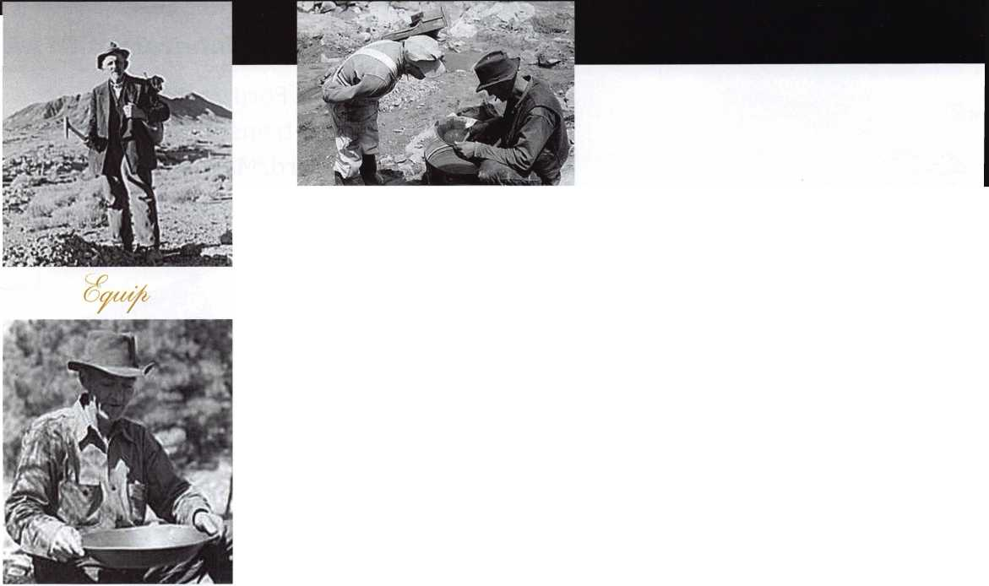

< ;

**You're never on your own..**

**Toll Free Tech Support**

**1**-**800**-**342-5080**

vv

"I've lost my Taurus keys...

can you make a new set?

How much of your money  
have you sent to the

local Ford dealer?

8008LA New Generation STAR

Use the Ford factory tool to  
program transponder keys for  
ALL Ford/Mazda vehicles.

Keep the money in your pocket!

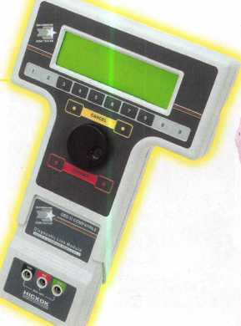

Complete

Ford/Mazda

transponder

coverage

NGS

PLUS the

ability to clear ALL

Diagnostic

Service Codes

Say "YES" to  
$100 phone calls



HICKOK

INCORPORATED

